Economics and Neurodiversity 3 - David Ricardo, Comparative Advantage, and Specialisation
David Ricardo 1772-1823 was an economist, businessman, and MP. Last year he was the subject of an edition of BBC Radio 4’s in Our Time , which is a wonderful listen. The podcast describes his life and ideas in much more detail than is possible in a short blog.
Ricardo is most famous for developing the theory of comparative advantage in 1817. This uses beautiful, elegant simple mathematics to explain how free trade could increase the wealth participating nations.
The same principle can apply to individuals with specialisms at work. The benefits are clearest when one party is better at one thing and the other something else, but the principle works even when one individual is better at producing both products.
Fig 1
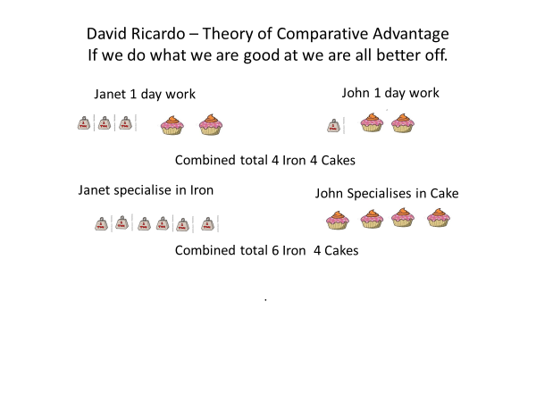

The law of comparative advantage has significant implications for Neurodivergent ND People. it suggests that within reason ND people are likely to succeed if they, focus on their strengths, do something they are passionate about and develop a specialism.
- ND people due to their spikey profile will tend to be good at somethings and bad at others, we therefore tend to be poor generalists but relatively good specialists.

- Frequently ND people will be able to make themselves among the best in the labour force in some job roles, if they are able to use these strengths, they will often be successful.

- An ND person who is not best at a subject they are passionate about at school, is also likely to succeed if they stick with their passion. Very often the people at school who are good at everything will move into professional low risk careers such as medicine, law, accountancy, or management which employ relatively few ND people, leaving the ND individual to be the best in their chosen specialism. (I need to stress that this is not say ND people cannot succeed in the professions many do. However focusing on strengths and passion and pathways others see as more risky can provide some ND people with a way to cut through competition in the labour market.)

- First Jobs are a particular challenge for ND People . Very often employers want their most junior professional staff to make themselves useful by doing anything which is needed rather than using specialist skills. It is Only when promoted that specialist skills come into play , but one only gets promoted by being a good generalist . This can be very frustrating for ND professionals.

Fig 2

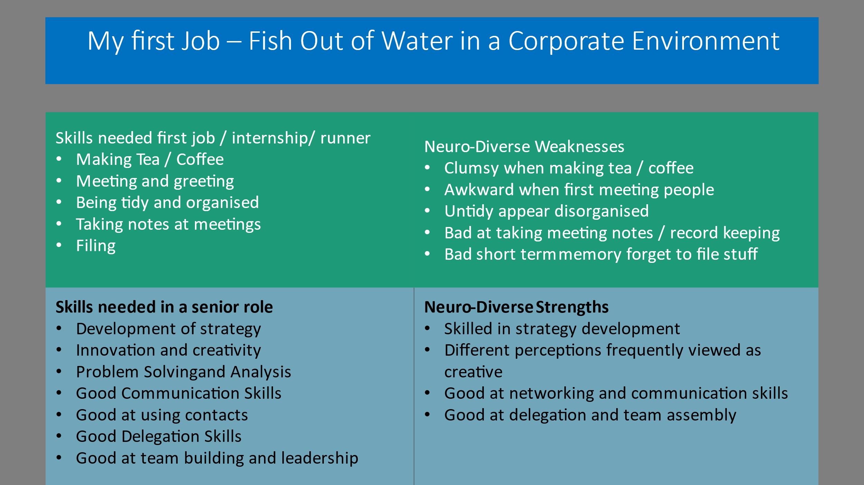

- Even when the ND person is not the best person in their chosen area. They are more likely to succeed if they focus on what they are best at and most enjoy, rather than trying to force themselves to do something they are bad at and hate.
Although the idea of focusing on strengths is attractive to most ND people, it is also problematic. In a society that expects people to take any available work. The necessity to earn both to survive and fulfil social expectations of society and family, can make it extremely hard for a ND person to find a job that allows them to play to their strengths. They will therefore all too often be forced to take the first available Job. (in a future blog I will talk about Marx’s idea of the alienation of labour and the way in which if worker is separated from the product of their labour this can lead to disillusion as I feel this speaks to the ND condition)
It is also much easier to specialise if you or your family are already financially secure. If you come from a family with a mortgage free home and both parents in employment, you are more likely to be encouraged to take a risky employment path (or self-employment) and follow your passion for creativity the environment or sport. On the other hand, if the family under financial pressure you will need to earn as soon as possible and may only be able to keep your specialist skills by pursuing a side Hussle or by volunteering.
The number of people who choose to be self-employed rises rapidly over the age of 50. Statistics are not available regarding how many of these over 50 year old who choose to become self-employed are ND . However, that given that ND people are more likely to self-employed than other member of population. It highly likely that many ND people when they feel secure will choose to work for themselves.

https://en.wikipedia.org/wiki/David_Ricardo
https://exceptionalindividuals.com/candidates/neurodiversity-resources/spiky-profile/
https://www.bayes.city.ac.uk/__data/assets/pdf_file/0003/367383/julielogan-dyslexic-entrepreneurs.pdf

