What Four Industrial Revolutions can teach us about the relationship between equality diversity and inclusion, and neurodivergence.
The way work has changed, over the past 250 years has had a profound impact on everyone not least neurodivergent People.
These changes are sometimes described as having occurred during 4 industrial revolutions. (more detail can be found in this series of Wikipedia articles)
Fig 1
Industrial Revolution | Rough Date | Driver | Technology Change | Change In work Mode
1st | 1765 | Steam | Increased mechanisation | Reduced agriculture and craft. Increased mining and primary industry more collective working.
2nd | 1870 | Gas & Oil | Increased mobility and technological advancement | Growth of factory working.
3rd | 1969 | Electricity and Telecoms | Use of electronic telecommunications and computers | Growth of Office Work and the Service Economy
4th | 2000 | Information Technology | Use of data, digital technology, the internet, AI and Robotics | Reduction in secretarial staff, self-supporting employees expected to use tech devices.

2) The implications of the changing workplace for neurodivergent people
  - Change in the workplace has not increased the number of Neurodivergent people but it has made neurodivergence more visible.
For most of human existence, ND people have been virtually invisible in the workplace. Dr Helen Taylor through her theory of complimentary cognition argues that through the age’s neurodiversity may have been crucial in helping communities adapt to change. ND people because they perceived the world differently, would provide alternative solutions to challenges. These would on occasions lead to progress or avert disaster. Pre mass education and industrialisation, Taylor suggests neurodiversity was often an asset to the individual rather than a liability.
Industrialisation increasingly removed the risk to businesses associated with individuality and creativity. Well before AI, It used iterative method and system design to drive continuous improvement. (Morgans Metaphors provide a good description of how some of this worked.)
Due to our spiky profiles ND people found the increasing requirement to be flexible , conform to company rules and fit in particularly uncomfortable. This increasing discomfort has created an illusion that the number of ND people is growing. This is not the case. The incidence of neurodivergence in the population is a constant. What has changed is that an increasing number of ND need help to fit in at work.
  - Education and economic growth have driven a growth in employment and some aspects of equality.
The history of work, the development of education and discovery of neurodivergence are inextricably linked.
Industrialisation required an increasingly skilled and educated workforce. This led to the growth of universal state education. It is no coincidence that at the time mass education was being introduced, dyslexia started to be observed (see a brief history of dyslexia) Throughout the 20th century levels of education attainment increased . Between 1901 and 2001 total employment in the uk economy rose from 16.5m to 30m
Table 2 - Achievement of O Levels / GCSEs, House of Commons Library
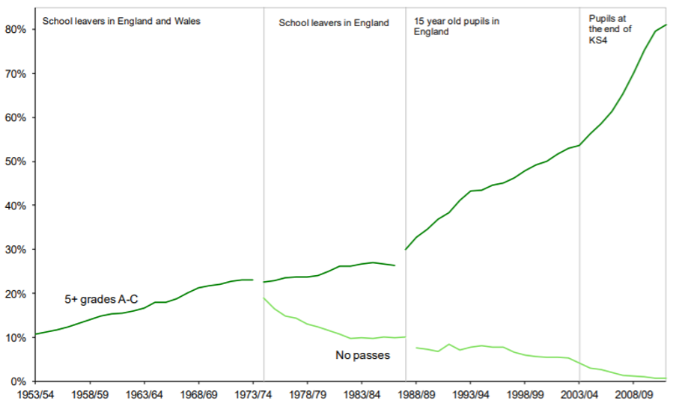
Source: Bank of England a Millennium of Macroeconomic Data
“We should teach the best that has been thought and known” Mathew Arnald 1822-88
Mass education is a driver of transparency and equality in the workplace. Public Qualifications make it possible to transparently view the level of education achieved by an employee. This apparent level playing field however disguises huge inequalities in support given to people trying to obtain these qualifications. None the less increased demand for skilled labour and improved education have enabled women and people from minority populations to become better represented in professional and managerial roles. Although arguably class barriers have been more resistant to change.

Senior Civil Service Employment.
 | Male | Female | BAME | Working Class
1996 | 83% | 17% | 4% (7%) | 18% (NA)
2020 | 54% | 46% | 9% (14%) | 18% (39%)
Figures in brackets () represent incidence in the population.
ND people have however frequently not been able to access support they require to succeed at school or in the workplace . In 2021-22 Access to Work the UK governments key form of support for people with disabilities who are in work supported 38 000 people. the number who are ND is hard to pin down but the dyslexia figures act as a proxy. Roughly 5 000 were dyslexic people receive access to work support. This is 0.2% of the estimated 3m dyslexic people in the UK labour force.
  - The origins of most equality movements lie in addressing inequalities faced by disadvantaged groups. A key strand in the neurodiversity movement is the desire to protect ND people who were included in employment from exclusion.
The equality movements of the 19th and 20th centuries have battles to give disadvantaged groups better to access to the education and the labour market. Classically these groups have included women, people from minority communities, people with disabilities, and people from working class backgrounds. Over past decades some of these barriers have painfully slowly started to be broken down. Many challenges remain.
ND people, particularly men started from a different position. They were invisible in the workplace. Many middle-class ND people probably invisibly occupied senior roles. Neurodivergence has tended to be revealed from the top down. As professional jobs became more tightly managed, and recruitment more transparent ND people found these jobs harder to secure. ND people have consequently become under represented in management and professional positions , and over represented in less secure freelance and self-employed positions. (see also Achievability e journal)
The Pace of change in the economy and education have accelerated. Safe refuses for ND people from all backgrounds have become harder to find. In the 80s and 90s male dominated employers such as mines, steelworks and dockyards shed labour. These employers had employed many school levers with few qualifications and provided secure well-paid jobs. In the 1990s and 2000s entry level qualifications for service sector jobs in the health service, care and retail, which employed many ND women rose making it harder for ND people to be invisible in these sectors.
Resolving the tension between neuroinclusion and The equality diversity and inclusion agenda.
In the post war period, middle class parents who expected their sons to work in banking, the law, medicine or management became increasingly aware that access to these jobs was becoming more competitive. If their children struggled at school, they needed to intervene.
Philip Kirby in his brief history of dyslexia points out, that the dyslexia movement was started by activist parents (often mothers) in the 60s and 70s Government and education authorities resisted providing this support. They feared it would be too expensive. They also stigmatised parents for being privileged, anxious , having sharp elbows and wanting to give their children an unfair advantage.
None the less, the activist parents often found a way to access support. Sometimes they would take the educational authority to tribunal, sometimes they would pay. The support worked increasing numbers of dyslexic and ND people started to go to university. After graduating they had greatly enhanced job prospects.
However the changes in the job market impacted on increasing numbers of people , it was not just middle class ND people who were at risk of being squeezed out of jobs. In 2020 you need GCSE English and maths to gain access to an entry level apprenticeship, the same qualification as were required to become a trainee teacher in the 1950s.
Governments reluctance to provide support to ND people consequently had most impact on those with least capacity to fight for support. If you lived in a deprived area, you would be less likely to get support than if you live in a more affluent area . Historically women have been less likely to be diagnosed than men, and people from black and brown communities have had less access to support than people from predominantly white communities. (see small axe education)
The consequences of government policy to restrict access to support for neurodivergent groups has been to amplify the disadvantage faced by already disadvantaged groups. ND people, particularly undiagnosed ND people, are among the most likely to be excluded from school , claim out of work benefits, become homeless , or face justice interventions. (see Amanda kirby’s post on homelessness)
The way neurodivergence has been allowed to magnify disadvantage is a result of a failure in Public Policy over many decades. To a very large extent we know what works in terms of early intervention and support for ND people. We know that in terms of life cycle costs it is cheaper to intervene early, than to not intervene. (see Dr Martin Bloomfield dyslexia Bytes)

https://en.wikipedia.org/wiki/Industrial_revolutions
https://complementarycognition.co.uk/
https://exceptionalindividuals.com/candidates/neurodiversity-resources/spiky-profile/
https://dyslexiahistory.web.ox.ac.uk/brief-history-dyslexia
Three Centuries of Data , Bank of England https://webarchive.nationalarchives.gov.uk/ukgwa/20160601171816/http://www.bankofengland.co.uk/research/Pages/onebank/threecenturies.aspx
https://commonslibrary.parliament.uk/research-briefings/sn04252/
Working Class Pay Gap – Guardian 2023 - https://www.theguardian.com/money/2023/nov/17/working-class-people-in-uk-paid-6000-less-for-same-professional-roles#:~:text=The%20data%20suggests%20the%2012,9.4%25%20in%202022%2D23.
https://assets.publishing.service.gov.uk/government/uploads/system/uploads/attachment_data/file/987600/SMC-NavigatingtheLabyrinth.pdf
Schools fail to diagnose 10% of Dyslexic Pupils BBC quoting Dyslexia APPG https://www.bbc.co.uk/news/uk-england-50095218
ADHD Crisis In The UK: Under Diagnosed, Lacking Support And Stigmatized, Dr Nancy Doyle Forbes 2023 https://www.forbes.com/sites/drnancydoyle/2022/01/14/adhd-crisis-in-the-uk-under-diagnosed-lacking-support-and-stigmatized/?sh=191be56396f4
Access to work Statistics https://www.gov.uk/government/statistics/access-to-work-statistics-april-2007-to-march-2022/access-to-work-statistics-april-2007-to-march-2022
https://www.bayes.city.ac.uk/__data/assets/pdf_file/0003/367383/julielogan-dyslexic-entrepreneurs.pdf
A brief History of Dyslexia Dr Phillip Kirby https://dyslexiahistory.web.ox.ac.uk/brief-history-dyslexia
Support for disabled students in higher education in England House of Commons Library 2021 https://researchbriefings.files.parliament.uk/documents/CBP-8716/CBP-8716.pdf
A Salutary Tale Of Two Neuro-Diverse, and Socially Diverse, Boys, Professor Amanda Kirby , Teaching Times https://www.teachingtimes.com/a-salutary-tale-of-two-neuro-diverse-and-socially-diverse-boys/
Special Education Needs and links to poverty Roundtree (Suggests dyslexia is under diagnosed in deprived areas) https://www.jrf.org.uk/report/special-educational-needs-and-their-links-poverty
Where have all the girls gone do-it-profiler https://doitprofiler.com/wp-content/uploads/2021/03/Do-IT-Where-have-all-the-girls-gone-report-ppt2021-Int-Nat-Womens-Day-_compressed-1.pdf
Under researched and under diagnosed - https://cognassist.com/underresearched_and_undiagnosed/
Amanda Kirby LinkedIn homelessness https://www.linkedin.com/posts/profamandakirby_neurodiversity-and-homelessness-activity-7024259212645933056-bHAr/
Dr Martin Bloomfield Dyslexia Bytes https://www.linkedin.com/posts/martin-bloomfield-dyslexia-bytes_want-to-know-something-really-simple-the-activity-7129951360392822784-4mSy?utm_source=share&utm_medium=member_desktop

