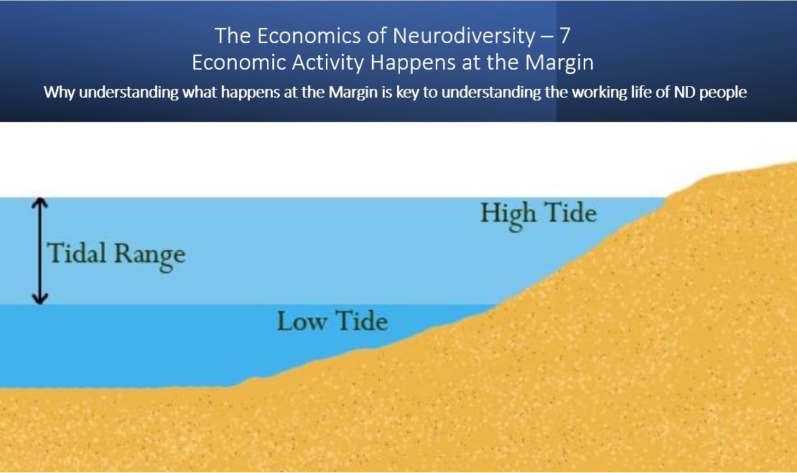

Introduction

When I was first taught Economics, I recall being told, economic activity most importantly happens at the margin. Economic decisions are made in relation to each incremental units, of consumption or production or employment.
This idea of Marginalism is key to several economic theories.
- The theory of Marginal Utility and the Law of Diminishing returns - Marginal Utility is the amount of extra benefit derived from using or consuming one extra unit of a product or service. The law of Diminishing returns suggests that after reaching a maximum the extra benefit derived of consuming successive units diminishes. For example, if you are a chocoholic like me, the first chocolate tastes great. The second chocolate sometimes tastes even better, but after eating a few it feels less good.

- Productivity and Marginal Costs of production - Similarly the cost of producing one unit of a product will frequently be high. Mass production may bring the unit cost of production down but at some point, the costs of production will rise again as the resources involved in the production process become more stretched. If staff need to work extra hours, they are likely to go on strike if they don’t get extra pay. Think of the health service.

- Price Theory - In classical economics the demand curve, expresses the amount a consumer will pay for each successive unit of a product. Given the law of diminishing returns, the unit price, is assumed to fall the greater number of units you buy. If you buy in bulk, you get a discount. By contrast the Supply Curve reflects the costs of production. This tends to rise as quantities get larger. In very cold weather, when demand for electricity rises, the marginal cost of production increases as extra power plants have to be bought online.

The market is the place where demand and supply meet. The price is fixed where the demand and supply curves cross. This determines the number of units bought and the price per unit at which they are bought. The price of oil is fixed daily. When during the pandemic demand fell, the price fell to near zero. Then countries such as Saudi Arabia which produce oil restricted supply leading to a price rise. International instability arising from the war in Ukraine, led to a further reduction in supply leading to a price spike.

Why the concept of Margins is helpful to the understanding of the impact of Neurodivergence

Both in education and in employment ND people form a sizable portion of the population where outcomes are uncertain.

Higher Education

In 1994 570 000 students enrolled on first degrees at UK Universities. Around 4% (23 000) identified as having a disability of which around 20% were Dyslexic (4 600 Students) at that time, no other ND conditions appeared in the statistics.
By 2021 1.6 million UK students were enrolled on First degrees. 17.3% of these identified as having a disability. (272 000) 6% of students (92 000) identified as having Specific Learning Difficulties such as Dyslexia, Dyspraxia and ADHD and 0.7% (11 000) students identified as having Social and Communication related disabilities such as Autism. Over nearly 30 years the number of ND students at university has increased 20 fold, the number of students with disabilities has increased 10 fold and the overall student numbers have increased 3 fold.
Many factors have contributed to this increase in ND participation in Higher Education.

- During this period awareness of ND conditions greatly increased, and the level of stigma surrounding ND conditions may have reduced. The number of people asking for diagnosis and support has therefore increased. Very little data is however available relating to the actual number of people receiving diagnosis for ND conditions.

- Higher education institutions have increasingly been encouraged to treat students as customers. Students have also partly because of the introduction of student fees seen themselves as consumers with rights to a level of service. The performance of universities is increasingly measured in terms of student outcomes, such as course completion and employment after graduation. Universities have therefore had a growing incentive to help ND students complete their course. Conversely restrictions on Special Educational Needs funding in schools, have led to a reduction in the numbers receiving support.

- However, it is also likely the incidence of neurodivergence, increases in each marginal 10% block of students entering HE. 100 years ago, a privileged minority of 2% or 3% went to university, some would have been invisibly neurodivergent. As free competition for places increased in the 60s, 70s and 80s people entering university from publicly funded schools tended to be drawn from a minority who were adept at passing exams. (Neurodiversity is not connected with high or low intelligence but it does impact on skills which make it easier or harder to pass exams). However, as the circle of participation grew outside this group, to include people who had been less good at navigating traditional academic pathways, the numbers of ND people in the cohort might be expected to increase.

Participation in higher education matters to the ND community. The Higher Education Statistics Authority data shows that graduates with Specific Learning Difficulties SpLD have almost the same chance of being in employment when they graduate as their fellow graduates, while unemployment rates among, SpLD non-graduates are roughly 2-4 times higher than they are in the general population. (Average unemployment is approximately 4%, Unemployment in the Dyslexic Community is around 12%) Autistic Graduates have more than double the chance of being in employment than autistic non- graduates.
Marginally increasing or decreasing participation in higher education, by for example:
- Setting higher or lower quoters / targets for university entry.

- Reducing or increasing student fees and the level of debt faced by graduates. Note the level of expected debt changes potential students’ perceptions of the risks and benefits they associate with participating in higher education.

- Making entry requirements expressed in terms of A level grades higher or lower. Or increasing or decreasing the discretion admission tutors have to accept different types of qualification or experience as evidence of meeting the criteria for admission.

- Raising or cutting funding for the courses which attract a disproportionate number of ND students (eg Creative Industry Related Courses)

- Making access to higher education easier or harder for ND students by changing the level of student support available to ND students
Will have a disproportionate impact on the ND community and their employment prospects.
Furthermore, privileged groups have historically enjoyed easier access to higher education, particularly the most selective universities than more disadvantaged groups. Each marginal widening of access disproportionately benefits more disadvantaged groups. Frequently members of these groups have least access to support for ND conditions, outside higher education. The widening of participation has therefore been of particular benefit in tackling the intersectional disadvantage faced by ND people from minority populations or ND people who grew up in deprived areas.

GCSEs

Obtaining GCSES particularly in English and Maths is the crucial gateway which needs to be negotiated in order, to obtain secure long-term employment. Good GCSEs are required to progress to 6th Form and follow the academic pathway to university. GCSE or equivalent qualifications are a requirement for an apprenticeship (at level 2, the entry level, you need to achieve GCSE passes or equivalent before you can complete the qualification).
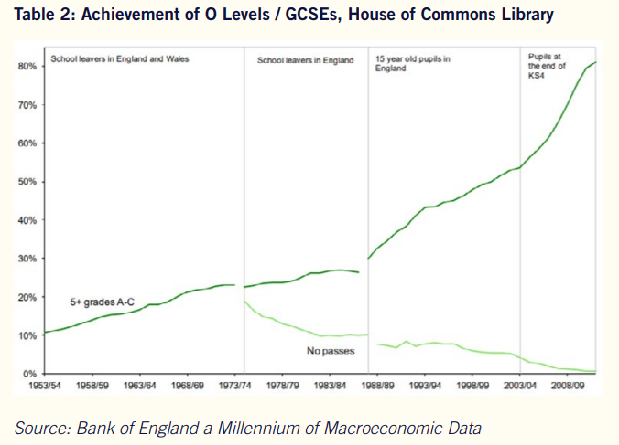

ND people are disproportionately represented in the marginal group who may under some circumstances pass or in other circumstances do not pass GCSES. In the 1960s only 20% of the population achieved 5 ‘O’ level passes. At that time neurodivergence, was one of many reasons why young people might not obtain qualifications. In the 60s the options for those who had not passed exams were also far greater. Not achieving ‘O’ level passes would therefore have less impact on the then largely invisible ND population.
By 2020 80% of people obtained 5 GCSE passes, and those who do not pass GCSEs have far more limited career or progression opportunities. Some people, possibly with profound learning disabilities are very unlikely to achieve 5 GCSE passes although they will always need support at school through special needs budgets and education and health care plans (EaHPs). Others will progress through school with little difficulty. Their achievement at GCSE will never be in doubt. However, the achievement of a group made up of perhaps 20% of pupils will be in doubt. With support this group will mostly pass (the success of independent schools, providing specialist support for ND students shows this to be the case). Without support many will not pass. ND people without GCSE passes are then at significantly high risk of unemployment. (In an article for Achievability I estimated that Dyslexic People without GCSE passes were two and half times more likely to be unemployed than non-ND people without qualifications). The life cycle cost of not providing support can therefore be high.
When SEN budgets are squeezed, quite rightly support for those with the greatest needs is least likely to be reduced. However, support for the marginal group, who may be most at risk of not gaining GCSEs, unless they have support is put at risk. Furthermore, because the greatest level of need tends to be concentrated in areas with the highest level of deprivation, this has a perverse consequence. As the Joseph Roundtree foundation describe more support for ND conditions such as dyslexia, tends to be available in more affluent areas than in more deprived areas. Furthermore, Professor Kirby explains parents with more resources and familiarity with how the system works are better able to access resources than those with arguably greater need but less capacity.

Employment

In the UK roughly 42m people are of working age. 32m are in employment. (Of these 28m are employed on a pay as you earn basis and 4m self-employed. 24m were employed full time and 8m part time. 9m people were classified as being economically inactive, 2m of these were students, others would be carers of parents or children or be suffering from long term illnesses or disabilities. A further group are taking a break from work and may have a job offer but have not started employment. 1.2m were unemployed and actively seeking employment.
The vast majority of the 32 million people in employment, move in and out of work with little friction. They usually work in a job they are content with, and can choose their mode of employment (Full Time, Part Time, Self Employed etc). This group might expect one or two periods of unemployment during a 45 or 50 year working life. A relatively small number of people will never work perhaps due to severe illness or disability. A larger group are temporarily not working due to study, or family commitments but will mostly move back into the labour market when circumstances change. These groups have a fixed employment status.
On the other hand, a group exists who during most of their working life sit or perceive themselves to sit on the margin between being employed and not being employed. This group finds it hard to move between jobs (and may therefore be reluctant to leave a job even when it is not right for them). They feel at risk of losing employment when times are hard. ND people make up a sizable portion of this group, but they are not the only people in this marginal category. Other groups such as older people in their 50s and 60s who for a range of reasons have had a spell out of employment also find it hard to get a new job. Many other people with disabilities can find themselves on the fringes of the labour market. Additionally, many ND people are in secure and healthy long term employment for much of their working life, so not all ND people are on the fringe of the labour market.
This marginality in the labour market takes many forms, not just unemployment. Some people seeking permanent work, will be forced to accept less secure and more informal work. This might mean accepting and clinging on to a non-optimal job, taking on temporary or part time work while looking for a better job. Others will become self-employed or work in the gig economy often earning far less than people in PAYE employment. (Some people in this category may successfully be able to trade-off income for greater control of their working life and possibly a better work life balance).
In other cases, people will become economically inactive either temporarily or permanently. This might mean a return to study to get better qualified or it might mean taking on a carer role or other form of unpaid family work. There by allowing other members of the family to develop their careers. People who get trapped in this zone of marginal employment risk losing financial and personal independence.
Conclusions
- ND people make up a sizable portion of the cohort who are on the margin of being able to be fully included in the labour force. At each of the key gateways in the education system, passing GCSEs or entering University, a marginal incremental increase in the group able to cross the threshold disproportionately benefits ND people, increasing their prospects of employment.

This is not an argument in favour of dropping educational standards or grade inflation. It is an argument for providing better education and more support for ND people. Better support will enable more people who have the capability to cross these thresholds to do so. This will greatly increase their employability and opportunities to fully participate in society.

It should also be stressed that education is not a competitive sport. Enabling an ND person to reach a level of attainment, which enables them to get a job, does not mean someone else will not pass an exam or get a job. The economy is skills hungry and decade after decade has increased the number of skilled people it is able to employ.

- The level of support available, and the decisions about who gets that support is frequently more about economics than either educational knowhow or the capability of an individual young person. The experience of independent schools who provide specialist resources for ND young people, shows that with support a very large proportion of ND people are capable of obtaining 5 GCSEs and many are able to progress to university. However, when schools are not able to provide this level of support many do not cross these thresholds. Those not supported in education or in worst cases excluded from school are at high risk of unemployment and social exclusion and in exceptional cases may end up on a pathway leading to justice interventions.

- The lack of diagnosis and support offered to young people in many publicly funded schools is an example of market failure. Over a person’s lifecycle, the benefits of enabling an ND person to fully participate in society, in terms of increased tax revenue, reduced cost of benefits, reduced costs of medical interventions etc, in most cases greatly exceed the cost of the catalytic support needed to help the ND individual progress in education or transition into employment.

Charles Freeman 2024

Marginalism Wikipedia https://en.wikipedia.org/wiki/Marginalism
Higher Education Statistics for the UK 94-95 HESA Table 2
Disabled Students and Higher Education – Department for Innovation Universities and Skills 2009
Higher Education Statistics Authority https://www.hesa.ac.uk/data-and-analysis/students/whos-in-he
Support for Disabled Students in Higher Education – House of Commons Library 2921
http://www.educationalneuroscience.org.uk/2022/04/01/why-has-there-been-a-rise-in-number-of-sen-children-especially-in-the-early-years/
Support for Disabled Students in Higher Education – House of Commons Research Briefing 2021 P9
The returns to undergraduate degrees by socio-economic group and ethnicity Department for Education, Institute of Fiscal Studies 2021
Apprenticeships in England
Education Historical Statistics – House of Commons Library 2012
How dyslexic People Work – Charles Freeman, Neurodiverse Voices in the time of Covid – Achievability e journal 2nd edition 2021
https://www.achieveability.org.uk/files/1675863828/achieveability-3rd-edition-neurodivergent-voices-calling-for-change-from-intersectional-perspectives-2022.pdf p18
Special Educational Needs their link to Poverty – Joseph Roundtree Foundation 2016 p9
A Salutary Tale of Two Neuro-Diverse, and Socially Diverse, Boys – Professor Amanda Kirby Teaching times 2021
Summary of Labour Market Statistics, Office of National Statistics, office of national statistics 2023
Income of the self-employed. department for business innovation and skills 2016 https://assets.publishing.service.gov.uk/media/5a7f648be5274a2e8ab4be81/self-employed-income.pdf
Neurodiversity and Exclusion From School – Amanda Kirby LinkedIn 2024 https://www.linkedin.com/posts/profamandakirby_neurodiversity-and-excluded-from-school-ugcPost-7136034817321644032-pJQY/?utm_source=share&utm_medium=member_desktop
Market Failure Wikipedia Article https://en.wikipedia.org/wiki/Market_failure
Neurodiversity, Equality, Diversity and Inclusion and the Levelling Up Agenda – Charles Freeman Achievability E Journal P18 2023 https://www.achieveability.org.uk/files/1675863828/achieveability-3rd-edition-neurodivergent-voices-calling-for-change-from-intersectional-perspectives-2022.pdf

