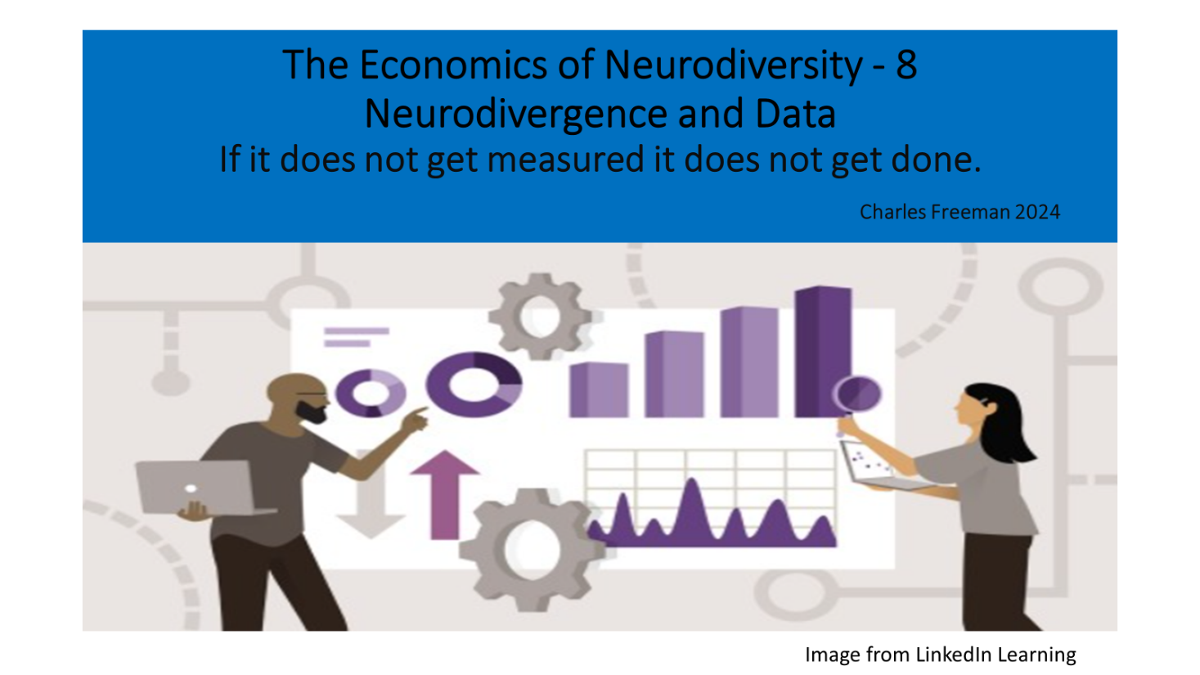

Introduction

It is frequently said if something does not get measured it does not get done. Lack of good data is one of the key barriers which makes it difficult for public bodies and businesses to measure the impact of neuro inclusion policies.
The Neurodivergent community suffers from a problem of triple invisibility.
- Neurodivergent (ND) people are frequently not visible to themselves - Most ND people are never diagnosed and therefore do not know they are neurodivergent.

- ND people are not visible to other people. You cannot tell if someone is ND by sight or casual observation.

- ND people are not visible in public policy. Without good quality data it is hard for public policy or equality Diversity and Inclusion (EDI) policy in businesses to measure differences between the experiences of ND people and other members of society.

Donald Rumsfeld former US Secretary of Defence said: (Wikipedia, 2002)
- There are known knowns. These are things we know that we know.

- There are known unknowns. That is to say, there are things that we know we don’t know.

- But there are also unknown unknowns, there are things we don’t know we don’t know. This category tends to be the difficult one.
I think this statement sums up the current state of play when considering, the data set relating to Neurodiversity, Neurodivergence and Neurominorities.

Understanding Terminology

Before considering the dataset relating to neurodiversity it is important to note, the language relating to neurodiversity, neurodivergence and neurominorities is still contested and still evolving. A recent article, 5 things you should understand about Neurodiversity in Psychology Today by Erin Bullus PhD and Abbey Sesterka and comment posted on linkedin by Tony Lloyd CEO ADHD foundation (Sesterka, 2023) illustrate this is a live debate. Personally, I am comfortable to describe myself as neurodivergent but can understand why people like Tony are uncomfortable with the term.
- The term Neurodiversity as Bullus and Sesterka point out embraces everyone. 100% of the population. The term deliberately draws on the concept of biodiversity making the parallel argument that everyone’s different style of thinking is valuable and contributes to the richness of society.

- Neurodivergence and Neurominorities - The way some peoples brains work, differs sufficiently from the norms for them to meet the criteria for diagnosis for a range of conditions . In most discussions about neurodivergence these conditions include Dyslexia, Dyspraxia (DCD), Dyscalculia, Dysgraphia, ADHD, Autism, and Tourette’s. However, this list is not exhaustive and debate exists about other conditions which should be included on the list.

- I am also aware many ND people are not comfortable in identifying themselves as having a Disability. Disability Wales explain this point well (Wales, 2024). However much of the employment protection ND people enjoy is embedded in disability rights legislation.

Known Knowns - What we think we know about the ND Data Set
It is frequently quoted that Neurominorities make up around 15% -20% of the Population (ICAEW, 2023). This figure can be calculated by combining the incidence of the listed conditions in the population and discounting the degree of overlap between these conditions.
Professor Amanda Kirby notes Co-occurrence is very common if not the norm with Neurodivergent Conditions. (Kirby A. , Neurodiversity 101 Co-occurance, 2021)
Figure 1 (Nursing)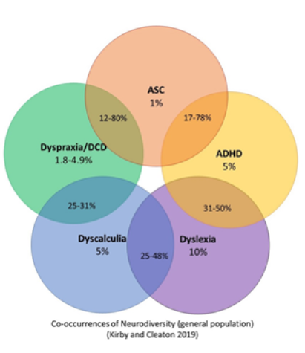
Professor kirby sets out her estimate of the level of co-occurrence to be as follows.
Table 1 (Kirby, Amanda Kirby Overlap, 2024)
 | First Diagnosis
Overlap With |  | DCD  Dyspraxia | ADHD | ASC /ASD  Autism | Dyslexia | Dyscalculia
Overlap With | DCD |  | 20%-50% | 10%-20% | 5%-15% | 5%-15%
Overlap With | ADHD | 20%-50% |  | 30%-50% | 15%-40% | 20%-30%
Overlap With | ASDC | 10%-20% | 30%-50% |  | 10%-15% | 10%-20%
Overlap With | Dyslexia | 5%-15% | 15%-40% | 10%-15% |  | 20%-40%
Overlap With | Dyscalculia | 5%-15% | 20%-30% | 10%-20% | 20%-40%
Data taken from Why Do We Find it so Hard to Calculate the Burden of Neurodevelopmental Disorders? Kirby and Cleaton, Journal of Childhood &Developmental Disorders 2018 (Cleaton, 2018)
The calculation of the 15% to 20% figure is however problematic for many reasons. Professor Kirby points out several researchers have identified different levels of co-occurrence between the listed conditions. (Kirby A. , Neurodiversity 101 Co-occurance, 2021) Estimates of the incidence of individual conditions in the population also vary greatly depending on the organisation providing the data.
Furthermore, the level of diagnosis of different ND conditions varies. Estimates of the number of Autistic people in the population are closely linked to the actual amount of Diagnosis. The widely stated figure is 1%, but some people believe the actual incidence including people who have not been diagnosed could be as high as 3% (Nion, 2023) The Estimate of the incidence of Dyslexia (10%) and ADHD (5%) by contrast is based on a statistical projection of how many people meet the criteria. (British Dyslexia Association, 2022) However, the rate of diagnosis for dyslexia is far lower. The British Dyslexia Association estimate only 20% of Dyslexic pupils are diagnosed at school. (BBC, 2019). The figure for ADHD is similar with only 10%-20% receiving treatment. (Doyle, 2022)
The differences between the projected estimate of neurodivergence in the population and the actual number who have received diagnosis, has important implications for the interpretation of data relating to neurodivergence.
- If actual numbers of diagnosis are used the ratio between the different ND conditions is flattened. The theoretical ratio between the incidence of Autism ADHD and Dyslexia in the population (ignoring the need to discount for co-occurrence) is expressed in the Kirby Cleaton Diagram as being 1% to 5% to 10% . However if only 20% of Dyslexic and ADHD people are diagnosed at school the ratio of, school age, people with a diagnosis would be 1% to 1% to 2%. In higher education the numbers diagnosed increases. The Higher Education Statistics Authority HESA suggest the ratio of students reporting autism or specific learning difficulties (all other ND conditions) is 1:7 . (HESA, 2021-22) This is far lower than the 1% Autistic to 15% Neurodivergent figure frequently quoted in literature relating to neurodivergence.

- Using actual numbers of Diagnosis as opposed to projected incidence reduces the ND population. The HESA statistics Suggest 7% of HE students are ND . this figure is less than half the projected estimate of 15% of the population being ND . While it might be expected that ND participation, in HE might lower than the overall average. The ND population in HE is however one of the highest incidence of disclosed neurodivergence I can find. ( The incidence of neurodivergence in known hot spot populations. EG Art Schools or the justice system is of course higher, but these populations can not be taken to be representative)

Known Unknowns -What we think we know is not as straight forward as it first seems.

Aside from the challenges with arithmetic discussed in the previous section , the assertion that 15% to 20% of the population are Neurodivergent is problematic for several reasons . I will highlight, three issues related to definitions, three issues related to input data, and three issues relating to the interpretation of data. My list is however not exhaustive.

4.1) Challenges with Definitions
The terms Neurodiversity, Neurodivergence and Neurominorities do not have a medical definition. language is constantly evolving, and no methodology has been agreed for quantifying their incidence. The following list outlines some of these issues.
4.1.1 - Lack of consensus regarding what conditions count as being part of the neurodivergence family - The framing of neurodivergence as just including Autism Spectrum Condition, ADHD, Dyslexia, Dyspraxia and Dyscalculia as depicted in figure 1 is uncomfortable. Professor Amanda Kirby convincingly argues through her Balls in Buckets analogy (Kirby A. , Balls in Bucket, 2021) that many people with ND traits do not fit the diagnostic criteria for any of the individual ND condition but will have similar traits, and experiences.
Professor Kirby also points out in a recent blog post “Neurodiversity 101 Newsletter, Navigating the landscape of neurodiversity, in awareness month”, (Kirby A. , 2023), that many people have acquired neuro-differences or conditions which co-occur with ND conditions. These conditions often have similar impact to the normally recognised ND conditions, Professor Kirby therefore encourages the ND community to be more rather than less inclusive of people who may wish to be viewed as part of the community.
This advice resonates with me. One of my early diagnoses in the late 1960s referred to minimum cerebral palsy. All the educational psychologists focused on my dyslexia, but the minimum cerebral palsy label stuck in my mind. I wanted a more definite diagnosis as I was aware of my difference but was frequently being told by family, friends, the media, teachers, and health professionals that dyslexia did not exist. It was not until a few years ago when Amanda Kirby explained to me, minimum Cerebral Palsy would now be described as DCD or Dyspraxia (Kirby A. , 2021) that the notes started to make sense. In the same conversation I was made aware of the closeness and overlap between DCD and Cerebral Palsy.
I am sure the concept of neurodivergence has further to evolve. My personal view is the group which identify with, and self identifies as being Neurodivergent. Is one of many neuro-tribes with a thinking style which differs from what is assumed to be the norm but the tile diagram of all these groups has not yet been fully mapped. (This continuing evolution is perhaps one of the key unknown unknowns).
Figure 2
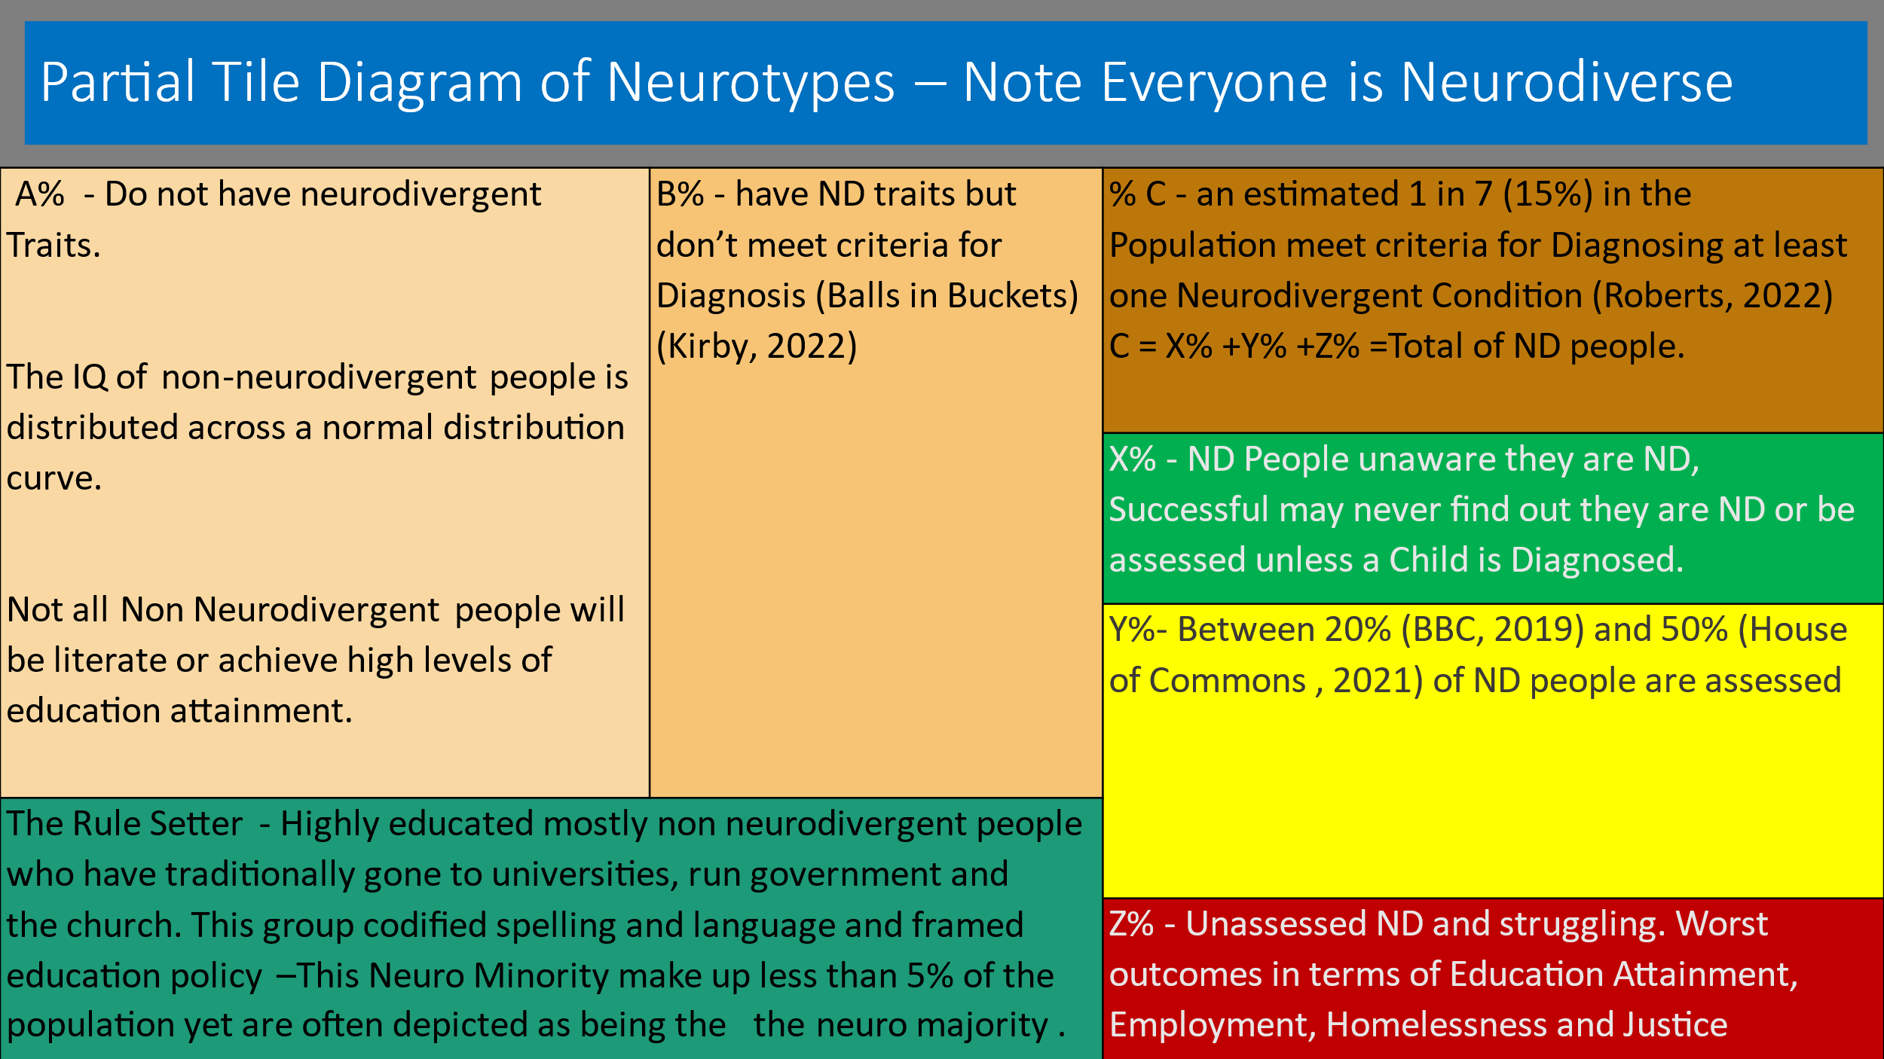
Charles Freeman 2024
Furthermore, I suspect the definition of our neurodivergent group may turn out to be as much about common experience as diagnosis of defined conditions. In terms of economics, I think on account of our different thinking styles, we form a group on the margin of the labour force. On the one hand we do not have a profound disability which excludes us from work indeed most of us want to work. On the other hand, we experience disadvantage in the labour market and during our working lives are significantly more likely to experience periods out of work than most people in the population.
Those of us lucky enough to have a diagnosis, usually gained the diagnosis because in some way we (or one of our children) struggled. Usually (but not always) the struggle leading us to diagnosis was with education or work. Post diagnosis most of us have also been able to achieve a level of success in education and at work when we have received appropriate support (reasonable adjustments).
4.1.2 - Different ND conditions are not consistently defined - Dr Martin Bloomfield in his Dyslexia Bytes Video Blog (Bloomfield, 2023) draws attention to the wide range of definitions used to define dyslexia worldwide. Definitions also change through . ADHD was not recognised as a condition in the UK until 2000 (LancUK, 2016). The definition of Autism was expanded to include Aspergers Syndrome in the 1990s (National Autistic Society, 2024). More recently it has been recognised that labels such as low or high functioning can be damaging. (Katy, 2024)
This lack of consistency of definition makes it hard to compare data over time, or on an international basis or indeed between different studies in the same country. Good Quantitative data is therefore extremely scarce.
4.1.3 - The Language used by official bodies is inconsistent – The UK Governments Disability Action Plan Consultation 2023-24 makes 13 mentions of neurodiversity (Gov.UK , 2023). Eight refer to the Department for Justice, which has a neurodiversity action plan. Other departments such as the Department for Health and Social Care, The Department for Work and Pensions and Department for Culture Media and Sport focus exclusively on autism. No Mention is made of Dyslexia or ADHD. The final Action Plan (GOV.UK, 2024) dropped the term neurodiversity altogether.
In its Outcomes for Disabled People Report the Office for National Statistics (ONS, 2021) publishes data relating to people with specific learning difficulties and autism, but does not use the term neurodiversity.
The Higher Education Statistics Authority collects data relating to students with a specific learning difficulty such as dyslexia, dyspraxia, or AD(H)D and students with a social/communication impairment such as Asperger's syndrome/other autistic spectrum disorder. (House of Commons , 2021) The Warnock Report in 1978 avoided using the term dyslexia instead referring to specific learning difficulties (Dr Kirby, 2007) . This term specific learning difficulty is used by many education authorities.
This inconsistency in use of language across government departments and within official statistics makes it hard to compare published data and relate the available data to the term Neurodivergent.
4.2 - Challenges with Input Data - The challenges relating to ND Data go beyond the discussions surrounding language and definitions. The base data relating to the diagnosis of each ND condition is based on Arbitrary Thresholds, Most ND people are never diagnosed so don’t know they are ND, and the methodology used in diagnosis has frequently been subject to class, gender, and racial bias.
4.2.1 - Diagnostic thresholds for ND conditions are arbitrary - The British Dyslexia Association (British Dyslexia Association , 2022) quotes an estimate that 10% of the population are Dyslexic. The European Dyslexia Association puts the figure at 9-12% with 2-4% experiencing a serious impact. (European Dyslexia Association, 2020) The Yale Centre for Dyslexia and Creativity (Yale Centre for Dyslexia and Creativity, 2022)uses a figure of 20%. The differences are explained by differences in definition and diagnostic threshold. The same differences are reflected in the range of estimates used in Table 1. Furthermore, as pointed out in Amanda Kirby’s balls in bucket analogy people 1% either side of a diagnostic threshold will have much the same traits (Kirby A. , Balls in Bucket, 2021). The point at which the threshold line is drawn for each individual condition is essentially arbitrary.
It is normal in statistical analysis to express the likely occurrence of a condition in a population as being within a range. Neurodivergence is however defined as a basket of conditions, the estimated range of occurrence is potentially very wide (much greater than the 15%-20% regularly quoted). Given both the uncertainty of the estimates and the breadth of the range it is difficult to make statistical arguments authoritative.
4.2.2 - The estimates of ND conditions in the population, greatly exceed the number of people who have had a diagnosis or been able to access support. - The BBC reflecting evidence given to the All-Party Parliamentary Group on Dyslexia reported that 80% of Dyslexic Children were not diagnosed (BBC, 2019) and did not receive support at school. ADHD UK quotes a similar figure for ADHD (ADHD UK, 2023). The (UK).
As stated earlier, Higher Education Statistics Authority HESA, reports one of the highest levels of disclosed neurodivergence in a population. HESA uses two categories as proxies for neurodivergence (House of Commons , 2021) In 2021 6.5% of graduates had a cognitive or specific learning difficulty and 1% had a communication impairment such as Autism. (HESA Dashboard, 2024) This suggests a total of 7.5% of graduates had disclosed a neurodivergent condition at university less than 50% of the 15%-20% estimate for the incidence of neurodivergence in the general population, but one of the highest disclosed populations identified by a public body.
On this basis most ND people will not know they are ND and will therefore not identify as being ND in surveys or disclose to employers. The actual level of disclosure is likely to be far lower due to the high level of Stigma associated with neurodivergence and a fear that disclosure (even in a confidential survey) could lead to discrimination. (Achievability, 2017)
4.2.3 - The diagnosis of individual ND conditions has historically been subject to significant biases - A recent Article in Scientific American highlighted the way in which cultural biases in the tests used to assess dyslexia frequently prevented Black Students from getting the support they required in order to fulfil their potential. (Carr, 2023) In recent years, the under diagnosis of women and girls with ADHD and Autism has been highlighted. (Kirby A. , Where have all the girls gone, 2021)The Joseph Roundtree foundation noted that the incidence of Dyslexia appeared lower in deprived areas than it is in more affluent areas. They speculate that this is down to under diagnosis. (Bart Shaw, 2016)
4.3 Challenges with Interpretation - Statistical Data relating to neurodivergence also needs to be interpreted with care. Low levels of actual diagnosis mean that comparisons with the estimated incidence in the population as opposed to actual number diagnosed may distort survey findings. People with different ND traits may not respond to surveys in the same way, leading to differential response rates, and changes in diagnostic definitions and methodology together with lack of available data makes timeseries analysis difficult.
4.3.1 - Studies often use the 15-20% estimated incidence of neurodivergence in the population as a benchmark, this significantly overestimates the numbers of ND people who will disclose in surveys - Some reports use the estimated incidence of neurodivergence in the population (15 to 20%) as a benchmark against which to identify an over or under representation in a population. This approach is problematic for at least two reasons. Firstly, less than half the ND population have a diagnosis, so at most around 7.5% of the population will be aware they are ND. Secondly even in a survey many ND people will choose not to disclose their neurodivergence. I am however not aware of a consensus about what figure should be used as a benchmark.
4.3.2 - The response rate to surveys of ND people with different traits appears to differ - Responses to the Neurodiversity in Business, neurodiversity at work survey, prepared by Birkbeck University in 2023 (McDowall, 2023) attracted a disproportionately high number of responses from people with ADHD and Autism and a disproportionately low response from dyslexic people . Anecdotally it was suggested that this might be attributed to ADHDers and autistic people quite enjoying completing surveys, as opposed to dyslexic people who actively dislike filling in forms. This would also explain the relatively low response by dyslexic people to many creative industry surveys (EG British Interactive Media Association Tech Inclusion and Diversity Survey (BIMA, 2019), Games Industry Survey (UKIE, 2022) UK Music Diversity Report (UK Music, 2022)and Inclusion and Diversity in VFX Animation and Post Production (Screen Alliance , 2019)) While HESA and many arts schools report large numbers of dyslexic graduate progressing into industry. (Rankin, 2015) It may also be that Dyslexic Graduates find it easier to mask at work, than autistic graduates and are therefore less likely to disclose their neurodivergence. (The balance between the benefits of disclosure in terms of reasonable adjustment and the risks in terms of discrimination, will be different for each ND person).
4.3.3 - Comparisons through time are difficult - The terms neurodiversity, neurominority and neurodivergence have only come into usage since the 1990s. The definitions of conditions which are generally regarded as being part of the ND family have also changed within the past 50 years. Professor Amanda Kirby suggests that frequently the diagnosis that an ND person receives depends on the Lens through which they are viewed by a professional. (Kirby, Which Lens do you Look Through, 2022). Most ND diagnoses only pick up 1 or 2 diagnoses even though a person may experience overlapping traits. In my case my diagnosis in the 1970s was for dyslexia and dyspraxia. I almost certainly also have dysgraphia but suspect strongly I may have ADHD and possibly autistic traits, but due to definitions available at the time I was diagnosed, these traits were basketed within my dyslexia diagnosis. This possibly would not be the case now.

5 Conclusions

5.1 - Absence of Evidence is not Evidence of Absence (Sagen, n.d.)- The weakness of the data set relating to neurodivergence does not undermine the validity of ND lived experience either reported through antidote or collectively in surveys.

The media frequently runs stories which cast doubt on the validity of ND experience. These often cause hurt and anxiety. The ND community should however be confident about the validity of their experience. The National Institute for Health and Care Excellence (NICE) and the National Health Service (NHS) recognise the validity of ND conditions including Dyslexia and ADHD. Growing quantities of anecdotal evidence point both to the successes and challenges faced by ND people.

ND experience is real. Collecting qualitative and quantitative data regarding the experience with in the ND community is valuable.

5.2 - Better Data would make neurodivergence more visible both within EDI work and public policy

Professor Ludmila Pavlova argues that ND people are the canaries in organisations and in society. We are the first to react to toxicity. (Praslova, 2022) Being able to track the way change impacts on ND people would therefore be valuable not only to the ND community but also to HR departments and policy makers.

While individual data sets for ND conditions e.g., autism, dyslexia and ADHD are useful. In my view we are also stronger together, not least as Amanda Kirby points out individual diagnoses rarely pick up the range of traits an ND person experiences. (Kirby A. , Neurodiversity 101 Co-occurance, 2021)

In order to strengthen the position of Neurodiversity as a dimension within both EDI policy and more generally within public policy a consensus on collecting and interpreting an ND data set is required.

5.3 - Developing an ND dataset is not impossible but will require pragmatism
Many organisations are already attempting to monitor neurodivergence within diversity surveys. The UK government until this year used the term within its disability strategy and action plan. However the way surveys ask questions, account for differentials in response rates and interpret responses is not consistent. This makes comparison between studies problematic.
Within Government different departments use different language to describe neurodivergence.
For the neurodiversity movement to move forward a more standardised approach to collecting and interpreting data is required. Such an approach would help both employers and public bodies.
The challenge requires pragmatism, a perfect definition of neurodivergence does not exist and we are still learning about the impact and incidence of neurodivergence, particularly undiagnosed neurodivergence.
The challenge seems similar to that faced by the UK Creative Industry sector in the late 1990s. The then Government decided it wanted to define a new industry sector, made up of many business groupings which had previously been viewed as separate - (Architecture, Advertising, Craft, Film & TV, Games, Publishing, Software Design, Visual and performing arts etc).
The new sector was first defined using a data evidence toolkit developed by Burns Owen Partnership (BOP) definitions and methodology have since evolved, but an authoritative data set has now emerged and been developed as a result of work by the Department for Culture Media and Sport DCMS, The National Endowment for Science Technology and the Arts NESTA and PEC. (The Creative Industries Policy and Evidence Centre)
Now is the time for academics within the ND community to develop a data evidence toolkit for neurodivergence which can be used as a template to authoritatively guide future research. This toolkit will not be written in stone and will need to evolve through time. Consistent data and a more standardised methodology would make it easier for the ND community to argue its case.

References
AchieveAbility. (2017). Neurodiverse Voices , Opening Doors to Employment. Retrieved from The Westminster AchievAbility commission for Dyslexia and Neurodivergence.
ADHD UK. (2023). Percentage Diagnosed vs Diagnosed. Retrieved from ADHD UK: https://adhduk.co.uk/adhd-diagnosis-rate-uk/
Bart Shaw, E. B. (2016). Special educational needs and their links to poverty. Retrieved from Joseph Roundtree Foundation: https://www.jrf.org.uk/child-poverty/special-educational-needs-and-their-links-to-poverty
BBC. (2019). Schools 'failing to diagnose at least 80% of dyslexic pupils'. Retrieved from BBC News : https://www.bbc.co.uk/news/uk-england-50095218
BIMA. (2019). Tech Inclusion and Diversity Survey . Retrieved from BIMA: https://bima.co.uk/wp-content/uploads/2020/01/BIMA-Tech-Inclusion-and-Diversity-Report-2019.pdf
Bloomfield, D. M. (2023). Dyslexia Bytes - The Definitions of Dyslexia . Retrieved from You Tube: https://www.youtube.com/watch?v=JhavNVcwWTo
British Dyslexia Association . (2022). Dyslexia Awareness Week. Retrieved from Britisg Dyslexia Association : https://www.bdadyslexia.org.uk/news/dyslexia-awareness-week-2022-2
Carr, S. (2023, December). Too Many Schools Are Misdiagnosing Dyslexia. Retrieved from Scientific American: https://www.scientificamerican.com/article/too-many-schools-are-misdiagnosing-dyslexia1/
Dr Kirby, P. (2007). A brief History of Dyslexia. Retrieved from University of Oxford: https://dyslexiahistory.web.ox.ac.uk/brief-history-dyslexia
European Dyslexia Association. (2020). What is Dyslexia. Retrieved from European Dyslexia Association: https://eda-info.eu/what-is-dyslexia/
Gov.UK . (2023). Disability Action Plan 2023-24 Consultastion. Retrieved from Gov.Uk : Disability Unit : Equality Hub: https://www.gov.uk/government/consultations/disability-action-plan-2023-to-2024/disability-action-plan-2023-to-2024-consultation-document#:~:text=The%20new%20Disability%20Action%20Plan,take%20in%202023%20and%202024.
HESA Dashboard. (2024). Student Charicteristics Disability. Retrieved from HESA Dashboard: https://tableau.hefce.ac.uk/t/Public/views/EandDofficialdashboard2022/Officialdashboard?%3Aembed_code_version=3&%3Aembed=y&%3AloadOrderID=0&%3Adisplay_spinner=no&%3AshowAppBanner=false&%3Adisplay_count=n&%3AshowVizHome=n&%3Aorigin=viz_share_link
House of Commons . (2021). Support for disabled students in higher education in England. Retrieved from House of Commons Library : https://commonslibrary.parliament.uk/research-briefings/cbp-8716/
Katy, E. (2024). History of Autism Brief Over View. Retrieved from Authenticaly Emily : https://www.authenticallyemily.uk/blog/the-history-of-autism-a-brief-overview
Kirby. (2022). Which Lens do you Look Through. Retrieved from linkedin: https://www.linkedin.com/posts/profamandakirby_dyslexia-dyspraxia-adhd-activity-6824209104924483584-W_VU/?trk=public_profile_like_view
Kirby, A. (2021, Febuary). Developmental Co-ordination Disorder (DCD). Retrieved from The association for child and adolecent mentle health: https://www.acamh.org/freeview/developmental-coordination-disorder-professor-amanda-kirby/
Kirby, A. (2021, Feb 18). Neurodiversity 101 Co-ocurance. Retrieved from X (Formaly Twitter): https://twitter.com/profamandakirby/status/1362306501130485764?lang=en
Kirby, A. (2021). Where have all the girls gone. Retrieved from Do it profiler: https://doitprofiler.com/wp-content/uploads/2021/03/Do-IT-Where-have-all-the-girls-gone-report-ppt2021-Int-Nat-Womens-Day-_compressed-1.pdf
Kirby, P. A. (2021). Coloured Balls in Bucket. Retrieved from Do It Profiler: https://doitprofiler.com/insight/wrong-coloured-balls-neurodiversity-diagnosis/
Kirby, P. A. (2023, October). Neurodiversity 101 - Navigating the landscape of neurodiversity in awareness month. Retrieved from Linkedin: https://www.linkedin.com/pulse/neurodiversity-101navigating-landscape-awareness-month-kirby/?trackingId=%2FCe9zD%2BHQu2Vhk76pCVadg%3D%3D
LancUK. (2016). History. Retrieved from https://www.lanc.org.uk/about-us-adhd-asd-assessment/our-history/
McDowall, A. a. (2023). Neurodiversity at work: demand, supply and a gap analysis. Retrieved from Birkbeck Institutional Research Online: https://eprints.bbk.ac.uk/id/eprint/50834/
National Autistic Society. (2024). The History of Autism. Retrieved from National Autistic Society: https://www.autism.org.uk/advice-and-guidance/what-is-autism/the-history-of-autism
Nursing, R. C. (n.d.). What is Neurodiversity. Retrieved from Royal College of Nursing : https://www.rcn.org.uk/Get-Help/Member-support-services/Peer-support-services/Neurodiversity-Guidance/What-is-Neurodiversity
ONS. (2021). Outcomes for Disabled People. Retrieved from Office for National Statistics: https://www.ons.gov.uk/peoplepopulationandcommunity/healthandsocialcare/disability/articles/outcomesfordisabledpeopleintheuk/2021
Praslova, L. (2022, June ). An Intersectional Approach to Inclusion at work . Retrieved from Harvard Business Review: https://hbr.org/2022/06/an-intersectional-approach-to-inclusion-at-work
Rankin, Q. (2015). Reballencing Dyslexia and Creativity at the RCA. Retrieved from Royal College of Arts : https://www.rca.ac.uk/news-and-events/news/rebalancing-dyslexia-and-creativity-rca/
Sagen, C. (n.d.). Absence of evidence is not evidence of absence. Retrieved from Journal of Applied Oral science : https://www.ncbi.nlm.nih.gov/pmc/articles/PMC10065758/#:~:text=%E2%80%9CAbsence%20of%20Evidence%20is%20not,of%20the%2020th%20century.
Screen Alliance . (2019). Inclusion and Diversity in VFX Annimation and Post Production. Retrieved from Screen Alliance: https://www.ukscreenalliance.co.uk/news/uk-screen-alliance-releases-ground-breaking-industry-diversity-inclusion-report/
Sesterka, E. B. (2023, October 5). 5 things you should understand about Neurodiversity Phychology today via linkedin post . Retrieved from Linkedin: https://www.linkedin.com/posts/erin-bulluss-a552b0a7_5-things-everyone-should-understand-about-activity-7115855446007025664-WkZx/?utm_source=share&utm_medium=member_android
UK Music. (2022). UK Music Diversity Report. Retrieved from UK Music : https://www.ukmusic.org/equality-diversity/uk-music-diversity-report-2022/
UKIE. (2022). UK Games Industry Census. Retrieved from UK Interactive Entertainment: https://ukie.org.uk/census2022
Wikipedia. (2002). There are unknown unknowns quote by Donald Rumsfeld. Retrieved from https://en.wikipedia.org/wiki/There_are_unknown_unknowns
Yale Centre for Dyslexia and Creativity. (2022). Frequently Asked Question. Retrieved from Yale Centre for Dyslexia and Creativity: https://dyslexia.yale.edu/dyslexia/dyslexia-faq/

