NDnomics 10- How Dyslexic (and other Neurodivergent) People Work – Charles Freeman – 2021 (Amended 2024)



This article was first published in the Achievability ejournal, neurodiverse voices good practice in the time of covid autumn 2021

Introduction

2022 marked the 50th Anniversary of the British Dyslexia Association (BDA). Since the 1970s significant changes have occurred in the UK Labour market. (Office of National Statistics, 2019) These changes have had a major impact on the way dyslexic and other neurodivergent people are employed. (The article uses data from a time when the term neurodiversity was not widely used so dyslexia is effectively used as a proxy for neurodiversity)
Data generated from a model I developed for this article suggests that over the past 50 years .
- The differences between the ways dyslexic and non-dyslexic people work have widened.

- The level of disadvantage faced by dyslexic people in the labour market has been amplified.

- Disadvantage impacts on dyslexic people who reach all level of educational attainment but has most impact on those with the fewest qualifications. Attending university almost eradicates the employment gap but does not secure equal pay or equal security of employment.

- Disadvantage faced by dyslexic people is compounded by poverty, and ethnicity.

Key Trends in the UK Labour Market

This section looks at some major labour market trends that have occurred in the past fifty years.

2.1 - Increased Female Participation in the Labour Market

Between 1970 and 2020 the employment rate for women rose from 52.8% to 72.6%. (Office for national Statistics, 2019b)

Table 1 - Male and female aged 16 to 64 years in employment, seasonally adjusted, UK, 1971 to 2018
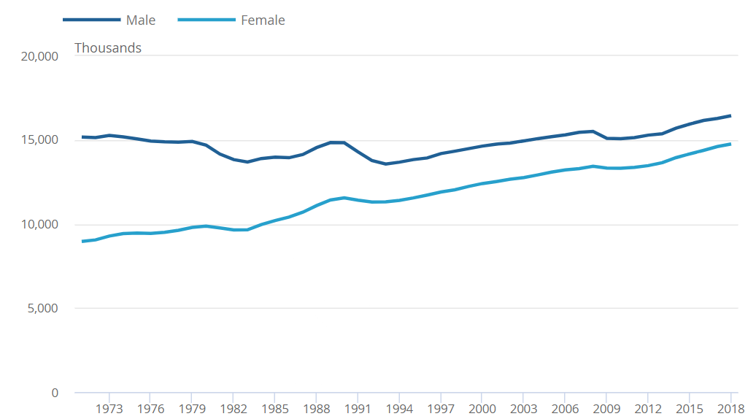
The rise in female employment has led to an increase in the number of dyslexic (and neurodivergent) people in employment. It may also have changed who gets assessed and accesses support. In 1970 Macdonald Critchley estimated that 4 times more boys than girls were dyslexic. (Critchley, 1970; p91) figures for the percentage of black or Asian people assessed at that time are not easy to find. (Kirby 2020)
In the 70s only 10% of newly qualified solicitors were female, by 2016 60% of solicitors were women. Similarly in 1982 only 0.25% of newly recruited solicitors came from Black or Asian communities. By 2015 this figure had risen to 14 % (Solicitors Regulatory Authority, 2017, p21; p12)
The people able to access assessments and support for neurodiversity related conditions frequently reflects the expectations of parent’s teachers and society regarding who might get a good job, rather than who needs support. This may be why Asher and Martin Hoyles asked, where are the black dyslexics? In the introduction to their book Dyslexia from a Cultural Perspective. (Hoyles, 2007) The incidence of dyslexia is now widely regarded as being close to equal among men and women and people of all backgrounds. (Readingwell, 2021)

2.2 - Changes in Education Attainment and Occupational Structure

In 1970 20% of the population obtained the equivalent of 5 GCSEs, by 2020 this figure increased to 80%. (House of Commons Library, 2012) 8% of the population participated in Higher Education in 1970, by 2020 this figure rose to 50%. (BBC News, 2019)

Table 2 - Achievement of O Levels / GCSEs, House of Commons Library
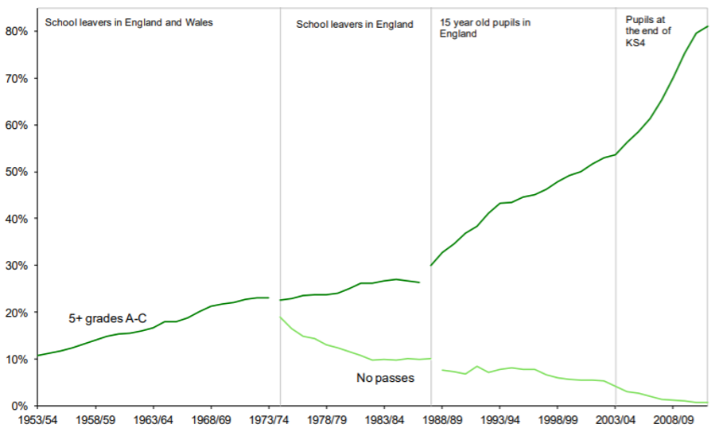
Source: Bank of England a Millennium of Macroeconomic Data

Professional scientific and technical jobs, (a loose proxy for graduate Jobs) have doubled in numbers during the past 50 years.
Table 3 - UK Employment by Sector (Office for National Statistics, 2017b)
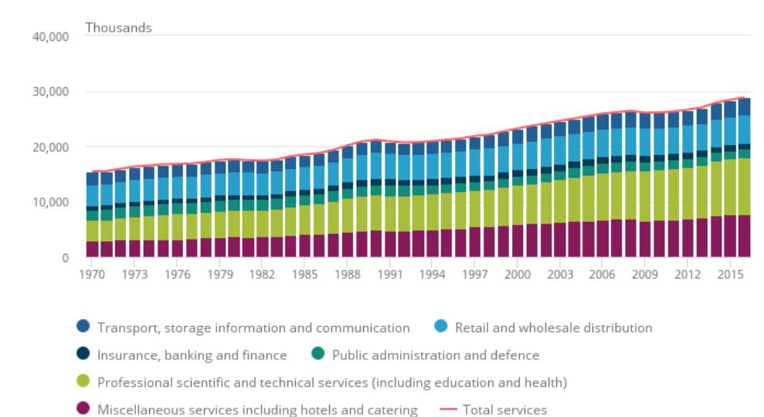
Source: Bank of England
In the early 70s most jobs were open to people with few qualifications. In 2021 it is necessary to obtain GCSEs to complete an entry level Apprenticeship. (Careermap, 2021)
Many people who started careers without qualifications in the 1970s, retired as skilled well-paid employees. Opportunities for career progression in posts that do not require GCSE or equivalent qualifications in English and Maths are now limited.

2.3 - Changes in mode of Employment

The level of self-employment in the economy has risen from 8% in 1971 to 14% in 2020. The 1970’s marked a low point in self-employment. One of the consequences of the period of postwar full employment was that the proportion of long-term secure jobs increased during the 1950s 60s 70s. Many jobs also came with good work-related pension schemes. Relatively few people needed to be self-employed.
In recent years the proportion of people who work in secure long-term jobs has fallen. An increasing number of people work on temporary contracts, in portfolio careers (doing more than one job at a time) or are self-employed. This should not always be seen as a bad thing; the flexibility can be very helpful. In security however also has consequences, making it for example much harder to buy a house or build up a pension fund.
Table 4 - Share of Employment that is self-employed UK 1861-2018 (Office for National Statistics, 2019f)
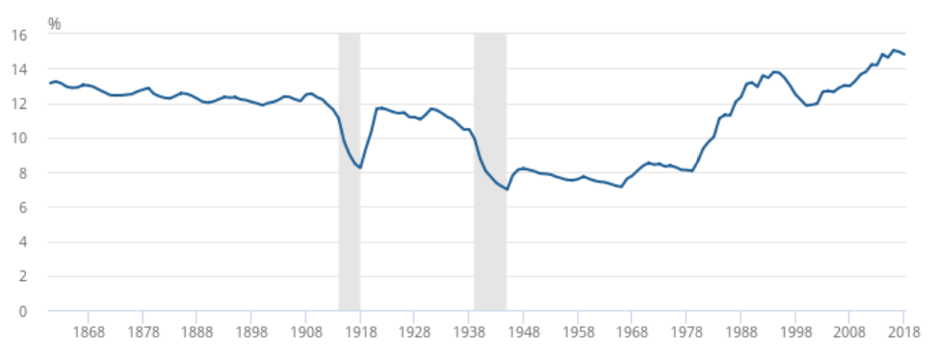 Source: Bank of England - A Millennium of Macroeconomic Data

An attempt to produce a model to compare the way dyslexics were employed in the 1970s with their mode of employment in the 2020s

Professor Julie Logan’s Research into entrepreneurship in 2000 & 2009 (Logan P. J., 2009) was ground-breaking in the way it drew attention to the high incidence of dyslexic entrepreneurs in both the UK and USA . Recently research has also identified the high incidence of entrepreneurs with other ND conditions such as ADHD (Archer, 2014).

Julie Logans work also provides some of the most accessible data relating to the way dyslexic people are employed. I have tried to use Professor Logans findings in combination with ONS data, to build a model which explores the differences between the way dyslexic people worked in the 1970s (often invisibly as few at that time had a diagnosis) and the ways in which they work now.

3.1 - Assumptions and limitations

Several assumptions are embedded within my model.
- The incidence of dyslexia in the population is 10% and constant through time. (NHS, 2018) Only a relatively small proportion of dyslexic people have a diagnosis (BBC, 2019). The number of people with a diagnosis is however increasing through time.

- The incidence of dyslexia among self-employed people is the same as that among entrepreneurs. Professor Logan estimates this figure to be 19%. Professor Logan however defined an entrepreneur as someone who ran a business rather than someone who was self-employed, to this end she excluded some self-employed people from her data set.

- The incidence of dyslexia among people employed in professional occupations is the same as that among corporate managers. This was estimated to be 3% by Professor Logan.

- Dyslexic people are as likely to be employed in non-graduate (pay tax as you earn, PAYE roles as non-dyslexic people. This may be optimistic as (Nomis, 2021) show that associate professional, administrative, and secretarial roles (office jobs) account for 58% of all non-graduate employment. Dyslexic people may face many of the same challenges sustaining this type of employment as they face in sustaining employment in professional roles.

The model has limitations.
- Professor Logan's sample size was small 215. The 95% confidence interval for her estimate of the incidence of dyslexia among entrepreneurs and corporate managers was (+ or – 2.5% and 5% respectively.) This was sufficient to support her findings regarding the prevalence of dyslexic entrepreneurs. However, when the data is combined with the ONS data the 95% confidence intervals widen as numbers grow larger. For the 1970 data they rise to + or – 3% for corporate managers / professionals, + or – 4 for entrepreneurs / self-employed and + or – 7 for the calculated figure for unemployment . For the 2020 data the confidence intervals for professionals are + or – 7%, for the self-employed they are + or – 8% and for unemployment they are + or – 14%. This means that it is not possible to be 95% confident of some of the comparisons between 1970 and 2020 which draw on data generated by the model. The figures are however illustrative of trends that are more likely than not to have occurred.

- The research was done at a point in time. Professor Logans UK research took place in the year 2000. In the 1970s the barriers to dyslexic people entering professional or office occupations were lower. Many managers had secretaries, psychometric testing was in its infancy, interviews were less formal and performance appraisals were rare. By 2020 barriers to entry had increased. It is therefore quite likely the percentage of dyslexic people who were in professional occupations in 1970 was greater than 3% and that this figure has continued to fall below 3% . Conversely the percentage of entrepreneurs who are dyslexic may have risen above 19%. Access to broadband and IT have made it easier to freelance. Furthermore fast growth sectors which employ a disproportionate number of Neurodivergent people such as the creative digital and tech industries (BIMA, 2019) also employ large number of freelancers ( (Creative Industries Federation, 2017)

- Dyslexia frequently carries stigma; disclosure can lead to discrimination. (Achievability, 2017) Dyslexic corporate managers may therefore have not accurately disclosed to Professor Logan.

3.2 - Findings

Table 5 - Model Findings – Calculation of Percentage of Dyslexic and Non-Dyslexic People working in different occupation categories.
1970 | Professional Scientific Technical Occupations | Other PAYE Employment | All PAYE Employment (Professional and Non-Professional) | Self-Employment | Unemployed
All | 13% | 75% | 88% | 8% | 4%
Dyslexic People | 4% (+ or - 3% | 75% | 79% | 15% (+ or - 4%) | 6% (+ or - 7%)
Non-Dyslexic People | 14% | 75% | 89% | 7% | 4%
2020
All | 31% | 51% | 81% | 14% | 4%
Dyslexic People | 9% ( + or- 7% | 51% | 60% | 27% (+ or – 8%) | 13% (+or-15%
Non-Dyslexic People | 32% | 51% | 83% | 13% | 3%
The Model Combines data from (Logan, 2001) (Office for National Statistics, 2017b) (Office for National Statistics , 2021)
The model suggests that the differences between the modes of employment experienced by dyslexic and non-dyslexic people have widened. In 1970 79% of dyslexic people and 89% of non-dyslexic people were employed in PAYE jobs, by 2020 this figure had fallen to 60% for dyslexic people and 83% for non-dyslexic people.
The percentage of dyslexic people who are self-employed had risen from 15% to 27%.
In 1970 a dyslexic person had less than twice the average probability of being unemployed. A Dyslexic person is now more than four times more likely to be unemployed than a non dyslexic person.

Implications and conclusions

In this section, I explore the implications of the trends in each category of employment for dyslexic and neurodivergent people.

4.1 - Managerial Professional and Scientific Jobs / Graduate Jobs

According to the House of Commons Library 6% of all Higher Education students have a specific learning difficulty (most often dyslexia) (House of Commons, 2021) This means possibly 30% of all dyslexic people are now going to university. (Given that the vast majority of dyslexic people are not assessed at school the percentage of dyslexic people progressing to university may even be higher than this figure see NDnomics 8 :Data) The House of Commons report goes on to show graduates with disabilities including dyslexia are nearly as likely to be employed as the average graduate.
Overall, 74% of graduates enter Managerial and Professional occupations (Markinstyle, 2021) However, Professor Logan’s research suggests dyslexic people including graduates are one third as likely to work in these occupations than non-dyslexic people. Dyslexic graduates while still being employed therefore appear to be more likely than non-dyslexic graduates to be employed in less secure occupations, to freelance or establish their own businesses.
This finding is reinforced by evidence in Creative Graduate’s Creative Futures, which suggests that in the creative sector at least, dyslexic graduates are as likely to be employed doing professional activity in the sector as non dyslexic graduates, but the mode of employment is more likely to be in temporary, self-employed or portfolio roles. (Institute of Employment Studies, 2009)
The Employment disadvantage for dyslexic graduates therefore appears to be mostly experienced in the form of less secure, lower paid employment rather than unemployment. It is important to note that Dyslexic graduate appear to be significantly more likely to be employed than dyslexic non-graduates. It could therefore be argued higher education is disproportionately valuable to dyslexic people.
Table 6 - Differences in the current activities of Creative Graduates
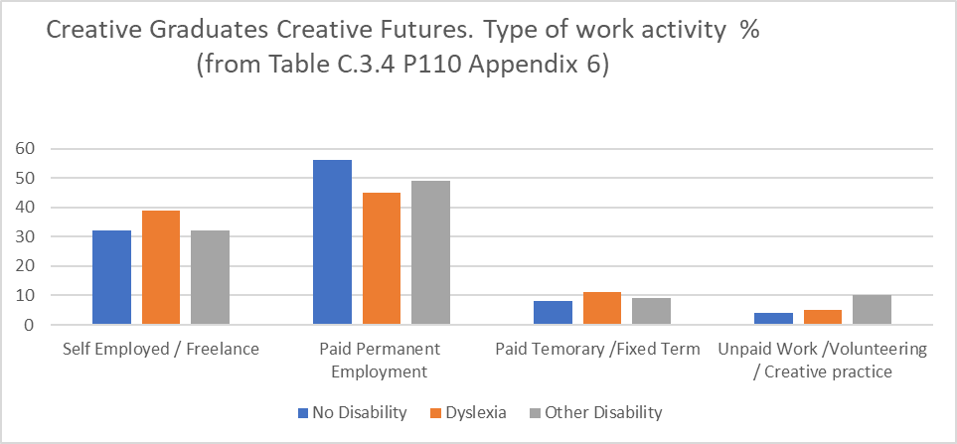
Source: Creative Graduates Creative Futures Institute of Employment 2009
Conclusion
Dyslexic graduates and professionals cannot rely on a supportive employer to nurture their talent. They need to be entrepreneurial in seeking employed or self-employed opportunities. They also need to take direct responsibility for the development of their own human capital.
Professional careers provide many graduates from disadvantaged backgrounds with a vehicle to achieve social mobility. The under representation of dyslexic people in these occupations makes it harder for dyslexic people to be socially mobile.

4.2 - Non-Professional Employment

According to the model in 2020 51% of dyslexic people are employed in non-professional jobs. The Government's Commission on Employment and Skills, future of work report notes that non-professional employment is becoming less plentiful and less secure. (UK Commission for Employment and Skills, 2014)
Conclusion
Support mechanisms such as access to work need to respond to this reduction in secure employment. Instead of helping employers to make reasonable adjustment, it would be more efficient to equip dyslexic people, to move with minimum friction between roles. This could be achieved by providing the individual not the employer with assistive technology and agreeing support such as job coaching directly with the individual. Agreed adjustments could be listed in a personalised support passport (GMB, 2019)

4.3 - Self Employment

The model suggests 27% of dyslexic people are self-employed, this compares with 13% of non-Dyslexic People. The incidence of self-employment differs with gender and age. (Gosimpletax, Self Employment Statistics, 2021) Twice as many men as women are self-employed. The percentage of people who are self-employed rises significantly among the over 55s. In the overall population 52% of self-employed people are graduates. It is likely that Dyslexic Graduates are particularly likely to become self-employed or freelance once their career has become established.
Conclusion
Entrepreneurship skills are a core element of a dyslexic (or ND) person’s survival toolkit. These skills need to be developed both in education and in the community. Self-Employed people are less well paid than people in employment but can achieve greater job satisfaction and flexibility. (Gosimpletax, Self Employment Statistics, 2021b) This flexibility is crucial for dyslexic people seeking to shape a work environment to fit their spiky profile (Genius Within, 2021)
The choice to become self-employed is much easier if you are financially secure and have a recognised skill. It is more difficult for younger dyslexic people or dyslexic people who do not own assets such as a house, car, or laptop, or for dyslexic people without qualifications, to follow this path.

4.4 – Unemployment

The model suggests the unemployment rate amongst dyslexic people is 13%. The figure estimated by the model is two and a half times the average for people with no qualifications (See Table 7). The employment disadvantage faced by dyslexic people, cannot therefore simply be explained by lack of education attainment.
Unemployment does not just impact the one in eight dyslexic people unemployed at any one time. All dyslexic people are likely to move in and out of employment more frequently and with more friction than non-dyslexic people. (In a 40-year career, the average dyslexic person will spend 5 years being unemployed) Fear of unemployment consequently impacts on work choices made by all dyslexic people.
Education attainment is disproportionately important in enabling dyslexic people to secure employment. While as discussed earlier dyslexic graduates are nearly as likely to be in some form of employment, as non dyslexic graduates. The likelihood of unemployment rises steeply in less qualified groups.
Table 7- Percentage of 16-to-64-year-olds, who were unemployed and not in full-time education, by ethnicity and qualification level - (ONS, 2020)

Highest qualification held | All | Asian | Black | Mixed | White | Other
All | 3% | 4% | 6% | 5% | 3% | 4%
Level 4 and above | 2% | 4% | 6% | 3% | 2% | 3%
Level 3 | 3% | 6% | 7% | 6% | 3% | 8%
Level 2 | 3% | 5% | 7% | 6% | 3% | 9%
Below Level 2 | 5% | 7% | 10% | 11% | 4% | 6%

Unemployment is not evenly distributed. It is concentrated in areas with highest levels of poverty. 40% of people on out of work benefits live in the 20% most deprived neighbourhoods. (HM Government b, 2010) Table 7 Highlights the way disadvantage is compounded by ethnic background, and lack of educational attainment. The model shows Dyslexia further amplifies the risk of unemployment by a factor of at least four. This would mean dyslexic people from some ethnic backgrounds, who live in the most deprived neighbourhoods and do not hold level two qualifications, will face unemployment rates of over 40%.
Conclusion
Professor Kirby (Kirby, A Salutary Tale Of Two Neuro-Diverse, and Socially Diverse, Boys - Teaching Times , 2021) (Kirby & Cleaton , 2018) rightly argues people living in the communities most likely to be disadvantaged by unemployment should be screened for neurodivergence at primary school. This would reduce the individual’s risk of unemployment and yield life cycle savings to society. (BBC NEWS, 2019a) Similarly, Job Centre plus staff need to be trained to recognise the disproportionate number of unassessed Neurodivergent People, who will seek their support.

4.5 – Data

This article uses data generated by a model. This data illustrates likely trends, but is not good enough to allow for academically valid statistical comparisons to be made, relating to all the changes in modes of employment, experienced by dyslexic people over the last 50 years. I used the model because little, actual data exists relating to the way dyslexic people are employed. Dyslexic or more generally neurodivergent people form the largest group of permanently disabled people who move in and out of employment. (DWP & Department for Health , 2016) & (ACAS, Achived 2021)

Conclusion
Better data would lead to better policy. Data relating to the incidence of dyslexia in deprived neighbourhoods and among people from minority ethnic backgrounds is particularly weak and unconvincing. Many studies quote that 40% of unemployed people exhibit dyslexic traits but have not been formally assessed. ( (Work and Pensions Committee UK parliament , 2012) It is also known 40% of unemployed people live in the 20% most deprived neighbourhoods. (HM Government b, 2010) It is therefore surprising we do not know how many dyslexic people live in these communities. The Joseph Roundtree Trust reported that the recorded apparent incidence of dyslexia is higher in more affluent communities. They go onto suggest this may be because of underassessment in deprived communities. (Joseph Roundtree Foundation p9; p17, 2016) Similarly, Professor Kirby has drawn attention to the lack of research relating to the incidence of dyslexia, or more importantly the assessment of dyslexia in minority communities (Kirby, Neurodiversity 101 Ethnicity Do It Profiler, 2020). We need to plug these gaps in the evidence base .

4.6 - The future

It is tempting to hope Dyslexic and Neurodivergent people will be welcomed back into mainstream employment by 2070. Technology will reduce the dominance of written communication. A talent hungry knowledge economy needs the creative abilities of the neurodivergent mind. Green and new craft businesses should provide more opportunities for everyone to gain employment by following their passion.
The future jobs report suggests this is not inevitable. The growth of AI could enable corporate employers to continue to marginalise employees who don’t fit in, People in non-professional and managerial occupation may face increased job insecurity (UK Commission for Employment and Skills , 2014)
Conclusion
Dyslexic and Neurodivergent people throughout their lives, therefore, need to be able to access catalytic support which releases their potential. This support should be designed to help them take ownership of their skills and shape employment pathways which do not rely on corporate employers.

Bibliography

ACAS. (Achived 2021). Neurodiversity at work . Retrieved from https://webarchive.nationalarchives.gov.uk/ukgwa/20210104113255/https://archive.acas.org.uk/index.aspx?articleid=6676
Achievability. (2017). Achievability Westminster Commission Opening Doors to Employent. Retrieved September 18, 2021, from https://www.achieveability.org.uk/files/1518955206/wac-report_2017_interactive-2.pdf
BBC News. (2019). The Symbolic Target of 50% at University. Retrieved September 18, 2021, from https://www.bbc.co.uk/news/education-49841620#.~.text=The%20proportion%20of%20young%20people,to%20go%20into%20higher%20education
BBC NEWS. (2019a). We Need to talk about dyslexia at work. Retrieved September 18, 2021, from https://www.bbc.com/worklife/article/20190702-we-need-to-talk-about-dyslexia-at-work
BIMA. (2019). Tech Inclusion and Diversity Report . Retrieved September 18, 2021, from https://bima.co.uk/wp-content/uploads/2020/01/BIMA-Tech-Inclusion-and-Diversity-Report-2019.pdf
Careermap. (2021). Apprenticeships Options for your Future Career - Can I get an Apprenticeship without any qualifications? Retrieved September 18, 2021, from https://careermap.co. uk/can-get-apprenticeship-without-qualifications/
Commons, H. o. (2012a). Education Historical Statistics House of Commons Library.
Creative Industries Federation. (2017). Creative Freelancers Report . Retrieved September 18, 2021, from https://www.creativeindustriesfederation.com/publications/creative-freelancers
Critchley, M. (1970; p91). The Dyslexic Child (2nd ed.). Heinemann.
DWP & Department for Health . (2016). Improving Lives The Work, Health and Disability Green Paper . Retrieved from https://assets.publishing.service.gov.uk/government/uploads/system/uploads/attachment_data/file/564038/work-and-health-green-paper-improving-lives.pdf
Genius Within. (2021). What is Neurodiversity. Retrieved September 18, 2021, from https://www.geniuswithin.co.uk/what-is-neurodiversity/#:~:text=%E2%80%9CSpiky%20profiles%E2%80%9D%20are%20a%20great,has%20large%20peaks%20and%20troughs.
GMB. (2019). GMB Reasonable Adjustment Passport Campaign. Retrieved from https://www.gmb.org.uk/campaign/reasonable-adjustment-passport
Gosimpletax. (2021). Self Employment Statistics. Retrieved September 18, 2021, from https://www.gosimpletax.com/insights/self-employment-statistics#:~:text=The%20largest%20percentage%20of%20self,%2D64%20are%20self%2Demployed
Gosimpletax. (2021a). Self Employment Statistics. Retrieved from https://www.gosimpletax.com/insights/self-employment-statistics#:~:text=The%20largest%20percentage%20of%20self,%2D64%20are%20self%2Demployed
Gosimpletax. (2021b). Self Employment Statistics. Retrieved September 18, 2021, from https://www.gosimpletax.com/insights/self-employment-statistics#:~:text=The%20largest%20percentage%20of%20self,%2D64%20are%20self%2Demployed
HM Government b. (2010). State of the Nation Report, Poverty Worklessness and welfare dependency in the UK. Retrieved September 18, 2021, from https://www.bristol.ac.uk/poverty/downloads/keyofficialdocuments/CONDEM%20-poverty-report.pdf
House of Commons. (2021). Support for Disabled Students in Higher Education in England. Retrieved September 19, 2021, from https://commonslibrary.parliament.uk/research-briefings/cbp-8716/
House of Commons Library. (2012). Education: Historical statistics. Retrieved September 18, 2021, from https://commonslibrary.parliament.uk/research-briefings/sn04252/
Hoyles, A. a. (2007). Dyslexia from a cultural prospective. Hansib.
Institute of Employment Studies. (2009). Creative Graduates Creative Futures Institute of Employment Studies. Retrieved September 18, 2021, from https://www.employment-studies.co.uk/resource/creative-graduates-creative-futures
Joseph Roundtree Foundation p9; p17. (2016). Special Needs and Their Links to Poverty. Retrieved from https://www.jrf.org.uk/report/special-educational-needs-and-their-links-poverty
Kirby & Cleaton . (2018). Why Do We Find it so Hard to Calculate the Burden of Neurodevelopmental Disorders - Journal of Childhood and Developmentle Disorders. Retrieved September 2018, 2021, from https://childhood-developmental-disorders.imedpub.com/why-do-we-find-it-so-hard-to-calculate-the-burden-of-neurodevelopmental-disorders.php?aid=23252
Kirby, P. A. (2020). Neurodiversity 101 Ethnicity Do It Profiler. https://www.linkedin.com/posts/profamandakirby_bame-and-neurodiversity-activity-6674552743832625152-j532/.
Kirby, P. A. (2021). A Salutary Tale Of Two Neuro-Diverse, and Socially Diverse, Boys - Teaching Times . Retrieved September 18, 2021, from https://www.teachingtimes.com/a-salutary-tale-of-two-neuro-diverse-and-socially-diverse-boys/
Logan. (2001). Entrepreneurial success: A study of the incidence of dyslexia in the entrepreneurial population and the influence of dyslexia on success. Ph.D. thesis, unpublished, University of Bristol, UK. Ph.D. thesis, unpublished, University of Bristol, UK. cited in Logan J 2010 https://www.cass.city.ac.uk/__data/assets/pdf_file/0003/367383/julielogan-dyslexic-entrepreneurs.pdf.
Logan, P. J. (2009). Dyslexic Entrepreneurs: The Incidence; Their Coping Strategies and Their Business Skills https://www.cass.city.ac.uk/__data/assets/pdf_file/0003/367383/julielogan-dyslexic-entrepreneurs.pdf. Dyslexia. Retrieved from https://www.cass.city.ac.uk/__data/assets/pdf_file/0003/367383/julielogan-dyslexic-entrepreneurs.pdf
Logan, P. J. (2009a; p13). Dyslexic Entrepreneurs.
Markinstyle. (2021). 15 Astonishing Graduate Employment Statistics. Retrieved September 18, 2021, from https://markinstyle.co.uk/graduate-employment-statistics/
NHS. (2018). Dyslexia. Retrieved from https://www.nhs.uk/conditions/dyslexia/#:~:text=It's%20estimated%20up%20to%201,has%20some%20degree%20of%20dyslexia
Nomis. (2021). Official Labour Market Statistics. Retrieved from https://www.nomisweb.co.uk/reports/lmp/gor/2092957698/report.aspx#tabempocc
Office for National Statistics . (2021). Employment and Labour Market . Retrieved September 18, 2021, from https://www.ons.gov.uk/employmentandlabourmarket
Office for National Statistics. (2017b). Changes in the UK economy since the 1970s Figure 5. Retrieved from https://www.ons.gov.uk/economy/economicoutputandproductivity/output/articles/changesintheeconomysincethe1970s/2019-09-02
Office for national Statistics. (2019b). Changes in the economy since the 1970s -Section 4, Employment levels by employment type, gender, sectors and subsectors. Retrieved Sept 18, 2021, from https://www.ons.gov.uk/economy/economicoutputandproductivity/output/articles/changesintheeconomysincethe1970s/2019-09-02
Office for National Statistics. (2019f). Long Term Trends in UK Employment - Figure 8 Share of Employment which is self employed. Retrieved September 18, 2021, from https://www.ons.gov.uk/economy/nationalaccounts/uksectoraccounts/compendium/economicreview/april2019/longtermtrendsinukemployment1861to2018
Office of National Statistics. (2019). Changes in the Economy since the 1970s. Retrieved from https://www.ons.gov.uk/economy/economicoutputandproductivity/output/articles/changesintheeconomysincethe1970s/2019-09-02
ONS. (2019). Retrieved from https://www.ons.gov.uk/economy/nationalaccounts/uksectoraccounts/compendium/economicreview/april2019/longtermtrendsinukemployment1861to2018
ONS. (2019c). Retrieved from https://www.ons.gov.uk/economy/nationalaccounts/uksectoraccounts/compendium/economicreview/april2019/longtermtrendsinukemployment1861to2018
ONS. (2019d). Long Term Trends in UK Employment 1861-1918. Retrieved from https://www.ons.gov.uk/economy/nationalaccounts/uksectoraccounts/compendium/economicreview/april2019/longtermtrendsinukemployment1861to2018
ONS. (2019e). Long Term Trends in UK Employment 1861 to 2018. Retrieved from https://www.ons.gov.uk/economy/nationalaccounts/uksectoraccounts/compendium/economicreview/april2019/longtermtrendsinukemployment1861to2018
ONS. (2020). Ethnicity Facts and Figures https://www.ethnicity-facts-figures.service.gov.uk/work-pay-and-benefits/unemployment-and-economic-inactivity/unemployment-by-qualification-level/latest. Retrieved from https://www.ethnicity-facts-figures.service.gov.uk/work-pay-and-benefits/unemployment-and-economic-inactivity/unemployment-by-qualification-level/latest
Readingwell. (2021). Dyslexia Statistics and Myth Busting Facts. Retrieved September 18, 2021, from https://www.dyslexia-reading-well.com/dyslexia-statistics.html
Solicitors Regulatory Authority. (2017, p21; p12). Mapping advantages and disadvantages: Diversity in the legal profession in England and Wales. Retrieved September 18, 2021, from https://www.sra.org.uk/sra/how-we-work/reports/diversity-legal-profession/
UK Commission for Employment and Skills . (2014). The Future of Jobs and work 2030. UK Government.
UK Commission for Employment and Skills. (2014). The Future of work Jobs and skills in 2030. Retrieved September 18, 2021, from https://www.gov.uk/government/publications/jobs-and-skills-in-2030
UK Commission for Employment and Skills The Future of Work. (2014; p80).
Work and Pensions Committee UK parliament . (2012). British Dyslexia Association Written Evidence . Retrieved from https://publications.parliament.uk/pa/cm201213/cmselect/cmworpen/576/576vw08.htm

Note According to the Department for Work and Pensions over 7m working people report a disability 60% of whom are economically active. ACAS state 15% of the population are Neurodiverse this equates to 6.3m people 70% of whom are economically active. Neurodivergent people while meeting government definitions of disability frequently do not identify as having a disability. They are therefore rarely acknowledged in official disability statistics.

