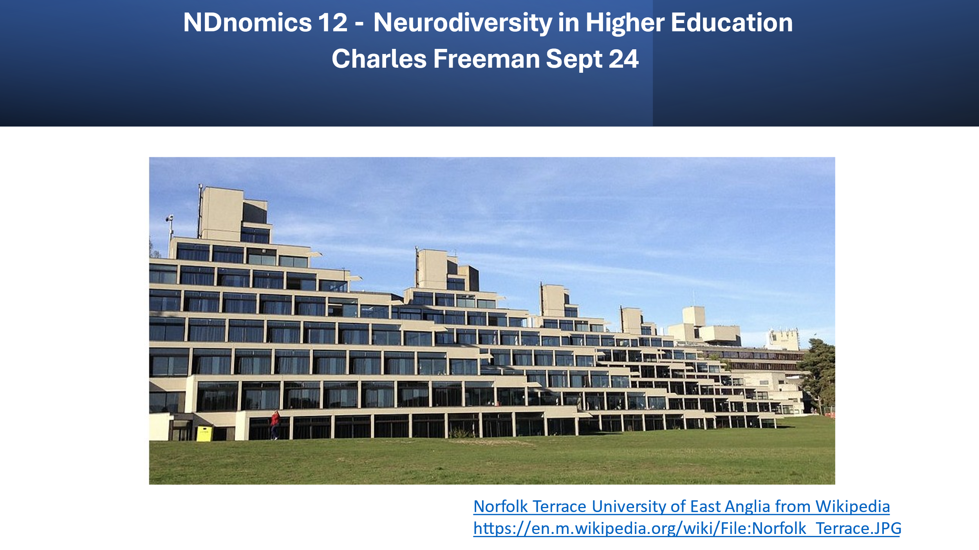

Introduction
This blog focuses on what the UK Higher Education Statistics Authority (HESA) data tells us, about neurodivergent students studying in higher education. Some of the questions I will seek to investigate include.
- What proportion of the ND population study for a first degree?

- How well do ND people do at university?

- What impact does gaining a degree have on the employability of an ND person?

- What Subjects do ND people study in HE and how does this impact employment options?

The blog is in many instances speculative. I frequently do not have all the answers. I plan to make this clear in the text. I would welcome any insights from people who may be better informed.

Definitions
In this blog, I will focus on the types of neurodivergence, featured in Mary Colly’s classic diagram (Colley, 2009) : Dyspraxia, Dyscalculia, Dyslexia, Autism Spectrum Conditions, ADHD, and Tourette’s (Tic Conditions)
The HESA statistics include two classifications that are closely mapped to neurodivergence.
- Cognitive and Learning Difficulties, this would cover dyslexia dyspraxia dyscalculia ADHD

- Social and Communication difficulties which would include autism and possibly TIC conditions

The data set also includes a classification for people with multiple disabilities and a classification for students with mental health conditions, some ND students will fall under these headings. I have not included these in my statistics.

What Percentage of Neurodivergent people progress to Higher education?

Table 1 – ND people at university

 | Cognitive or Learning Difficulties (Dyslexia ADHD etc) | Social and Communication Difficulties (Autism) | All Students
Total Number of Students enrolled 2018 (Percentage of all students) (HESA , Accessed 2024) | 21,940 (5.5%) | 3,470 (0.9%) | 401,250
Total Number of first-degree qualifiers 2021 (HESA , Accessed 2024) | 20,760 (6.70%) | 2,750 (0.9%) | 311,920
Withdrew from University after first year. (Bolton, 2021) | 8.5% | 11.3% | 9.8%
Diagnosed at University Calculation from HESA | 5,381 (1.34% of students receive a diagnosis at Uni). | 602 (0.15% of students receive an autism diagnosis for the first time at Uni)
Graduate Progression to Highly Skilled employment or further study (Bolton, 2021) | 73.3% | 61.8% | 73.3%
The proportion of students obtaining 1st or upper-second-class degrees | Not Available (likely to be between 79% and 83%) | 79% (Autism North East, 2019) | 83.6% (Bolton, 2021)
Unemployed 15 months after graduating (Drakeley, 2022) | 7.8% (SPLD) | 16.7% | 7.7%

3.1) Roughly 1/3rd of Autistic Young people go to university
In 2019 the symbolic target of 50% of young people progressing to university in the UK was reached. (BBC 2, 2019) Due to the complexity of the ND data set estimating the proportion of ND people who participate in higher education is challenging. (See NDnomics 8 Data) . (Freeman 1, 2024)
The data relating to the social and communication challenges/autism category is slightly clearer than that for cognitive and other learning difficulties (including Dyslexia.) The National Autistic Society estimates approximately 1% of the population are Autistic. (National Autistic Society 1, 2024) However, the national autistic society also estimates 160 000 autistic young people attend schools in the UK, (School Report 21, 2021) . A total of 10.6 million pupils attended school in 2021-22 (Clark, 2024). It can therefore be estimated that roughly 1.5% of school pupils are autistic.
The HESA data suggests the number of autistic students entering UK universities rose steeply from 0.2% in 2010 to 0.9% in 2020. (HESA , Accessed 2024) This suggests Autistic people are underrepresented at university by a factor of approximately 1/3rd. Given that 50% of all young people attend university, it can be calculated that 30% of autistic young people who have been diagnosed at school or preschool go to university.

3.2) My guess is that 40% of Non-Autistic ND people attend University
The Data for Non-Autistic ND people is quite hard to pin down and less consistent than the data relating to autism. It is widely estimated that 15 to 20% of the population are Neurodivergent. (The Guardian , 2023) . However, a large proportion of Dyslexic people, people with ADHD and other Neurodivergent conditions are not diagnosed or supported in school. For both ADHD and Dyslexia, a figure of 80% under-diagnosis is regularly quoted. (BBC 1, 2019). This would suggest 2-3% of the school population have been diagnosed with ND conditions excluding autism. The HESA Data suggests 5-6% of students entering HE have a cognitive or learning difficulty this figure is higher than the figure diagnosed in school. (I find this problematic and would welcome help in understanding at what point the 2-3% of university entrants who were not diagnosed at school, gain a diagnosis before entering university. In some instances, this will be at FE colleges but a gap in the stats still seems to exist, any help is welcome )
Based on this data, it is impossible to estimate, the proportion of Non-Autistic ND people who progress to university. Given the employment rate for Non-Autistic ND people is higher than that for Autistic people but lower than that of people in the rest of the population. It is likely the same pattern applies to participation in higher education. My pragmatic guesstimate is therefore that between 30% and 50% of Non-Autistic ND people attend university. My instinct is that the likely figure is around 40%. I openly declare this to be a guess. If anyone can point to a more solid statistic, please let me know.

How well do ND students do at university?
Overall, the evidence seems to suggest ND students do pretty well at university. In general, they seem to have a better experience than at school, where many fail to access diagnosis and support, or in employment where they are significantly underrepresented in the securely employed, full time labour force, and risk being pushed into lower-paid tempory or freelance work.. (See NDnomics 2 Employment) (Freeman2, 2023)
Anecdotally many ND people report that university can be the place where things fall in place, and they learn to accept their neurodivergence and how to work to their strengths. In Black Brilliant and Dyslexic, Zoe-Jane Littlewood states “Going to University was a pleasant, unexpected experience” (Brissett-Bailey, 2023).
All is not rosy. Some ND students particularly autistic students report having a bad experience. (Bristol University, 2019). Changes in Disability student allowance have made it more difficult for universities to support ND students. I have also heard disappointing reports, that fellow students resent adjustments such as extra time in exams or the provision of support tutors, which are made available to some ND students. Fellow students sometimes Claim these reasonable adjustments give ND students an unfair advantage.

3.1 Continuation Rates
The Data is encouraging. The House of Commons Library Report Disabled Students in Higher Education draws on HESA data (Bolton, 2021). This report suggests that the continuation rate for students after the first year is only slightly lower for autistic students than the average for all students. On average 9.8% of starters did not continue into a second year , for autistic students the figure was 11.3%. This finding is broadly consistent with figures quoted by Autism North East . Autism North East suggests 36% of Autistic students do not complete their course, which is slightly higher than the average figure for all students. 29% of all students do not complete their studies. (Autism North East, 2019) Autism Northeast go on to suggest that one reason for the higher-than-average withdrawal rate is that only 21% of Autistic students get the support they require at university.
The data for dyslexic and other students with cognitive difficulties is even more encouraging. The House of Commons report suggests these students are less likely than the average student to leave their course after the first year.
During their time in Higher Education, quite large numbers of students will receive a diagnosis for Autism or other ND conditions. My calculation from the HESA data indicates around 600 students (22% of autistic graduates) , will get a first time diagnosis during their time at university. Further more over 5000 students , or 24% of Non Autistic ND graduates will get a first time diagnosis while studying in HE .

4.2 Grades
The Autism Northeast report indicates 79% of autistic students who complete their final year, gain a first or upper-second-class degree. I cannot find equivalent figures for the cognitive difficulties category, but it seems unlikely this will be much out of line with the overall figure for students with disabilities 82.3%. This figure is slightly lower than the average for students without a disability 83.6%.

4.3 Employability
Neurodiverse Graduates appear to have significantly better employment prospects than, neurodiverse non-graduates. It is important to note correlation does not necessarily imply causation. It is likely that the traits that enable an ND person to enter higher education and complete their course, may give them better employment prospects, regardless of the university experience .
The House of Commons report specifies that 73.3% of non-disabled students progressed to High Skilled Employment or further study. Dyslexic and other students with Cognitive or Learning Difficulties achieved these outcomes at the same rate as students without a disability. 61.8% of Students with Social or Communication difficulties achieved the same outcome.
The Association of Graduate Career Advisory Services provides greater detail than the House of Commons library report their findings are set out in table 2 .

Table 2 - Graduate outcomes by disability type for first-degree graduates (% figures) 2019 (Drakeley, 2022)

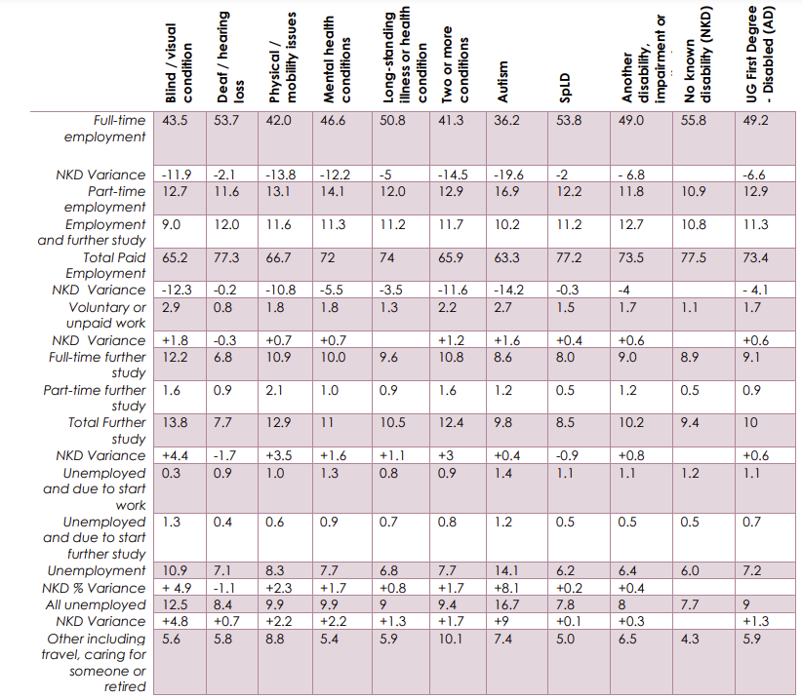

In total 63% of Autistic Graduates are in employment, 36% full-time employment. A further 10% progressed into further study, 17 % were unemployed after 15 months and 7% are outside the labour force engaging in activities such as travel or caring. These figures are substantially better than those experienced by autistic non-graduates. The national autism Society estimates only 23% of all autistic people are in employment 14% are in full-time employment. ( National Autism Society 4, 2016) Autistic Graduates are therefore at least twice as likely as autistic non-graduates to be in work.
For graduates with cognitive or learning difficulties, the employment gap almost closes. 77.2% being in paid employment compared to 77.5% of graduates without a disability. The unemployment rate after 15 months, for this group 7.8% compared to 7.7% for graduates who do not have a disability. Dyslexic Non-Graduates experience and unemployment rate 3 or 4 times higher than that experienced by the general population. (See NDnomics 10 – How Dyslexic and other Neurodivergent People Work ). (Freeman3, 2024)
The House of Commons report however notes that graduates with disabilities are more likely to be in temporary employment, part-time work or have multiple jobs than graduates without a disability. Graduates with a disability also tend to earn less than graduates without a disability. 27% of graduates with a disability earned less than £21 000 15 months after graduating, compared to 23% of graduates without a disclosed disability. Similarly, only 24% of graduates with a disability were earning over £ 30,000 compared to 31% of graduates without a disability. It is likely these lower levels of earnings will also apply to ND graduates.
The House of Commons findings are in line with the findings of the 2010 Creative Graduates, Creative Futures report. This report focused exclusively on the creative sector and provided a good picture of prospects for dyslexic creative graduates.
Chart 1 - Dyslexic Students are more likely to portfolio work in the creative sector than non-dyslexic graduates. (Institute of Employment Studies, 2010)

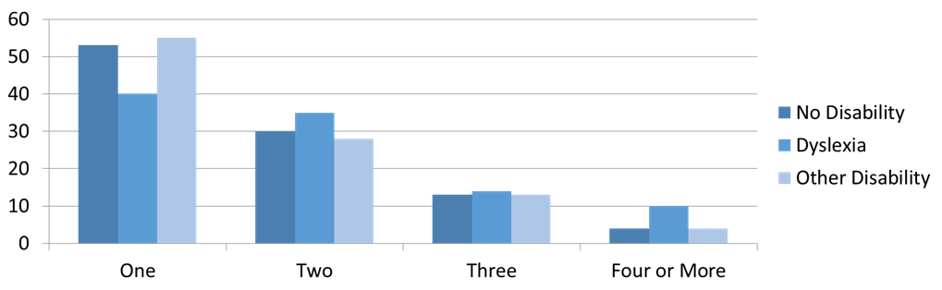

Chart 2 - Dyslexic Creative Graduates are more likely to freelance or be in temporary employment than Non Dyslexic Creative Graduates, (Institute of Employment Studies, 2010)
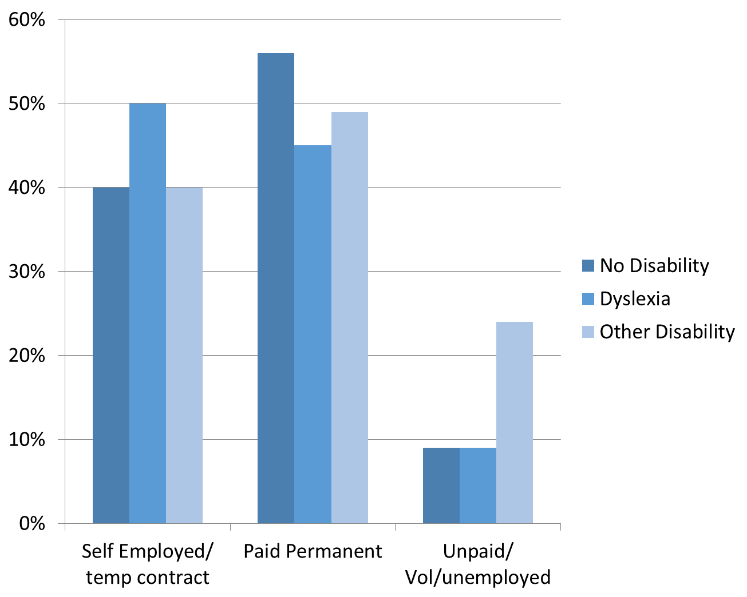

Which Subjects do ND Students Study
Table 3 - Extracted from HESA data on students with disabilities at UK universities. Workbook: E and D official dashboard 2022 (hefce.ac.uk) Apologies for small and not very accessible font size due to cut and paste from excel)
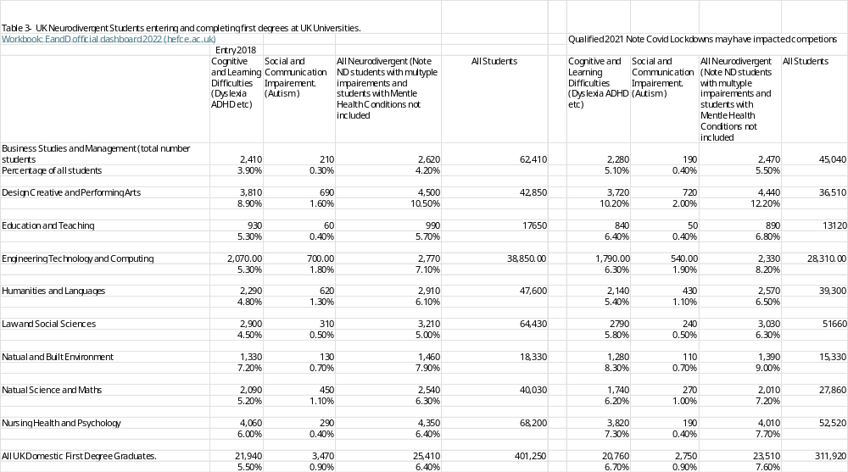

Table 4 - Most Popular Subjects by Graduates (HESA , Accessed 2024)
Top 5 Subjects with Most Graduates All Students |  |  |  | Subjects with Most Graduates, Students with Cognitive or Learning Difficulties. (Dyslexic etc) |  |  |  | Subjects with Most Graduate Students with Social and Communication Difficulties (Autism)
Subject | Number | % All  Students |  | Subject | Number | % All  Dys etc  Students |  | Subject | Number | % Autistic  Students
Nursing Health and Psychology | 52,520 | 16.8% |  | Nursing Health and Psychology | 3,820 | 18.4% |  | Design Creative and Performing Arts | 720 | 26.2%
Law and Social Sciences | 51,660 | 16.5% |  | Design Creative and Performing Arts | 3,792 | 17.9% |  | Engineering Technology and Computing | 540 | 19.6%
Business Studies and Management | 45,040 | 14.4% |  | Law and Social Sciences | 2,790 | 13.4% |  | Humanities and Languages | 430 | 15.6%
Humanities and Languages | 39,300 | 12.6% |  | Business Studies and Management | 2,250 | 10.9% |  | Natural Science and Maths | 270 | 9.8%
Design Creative and Performing Arts | 36, 510 | 11.7% |  | Humanities and Languages | 2,140 | 10.3% |  | Law and Social Sciences | 240 | 8.73%

4.1 ND Students Graduate from all Subjects but cluster slightly more tightly than the rest of the student population.
ND students are studying for degrees in all of the broad subject categories used by HESA. Even in medicine and veterinary science, 6.6% of graduates declared a cognitive or learning difficulty. (HESA , Accessed 2024) (Medicine is not included in the above table as the course length is not comparable.) However the subjects chosen by ND students are more clustered. 80% of Autistic Students study the 5 most popular subject areas within the autistic community. 70% of non-autistic ND students study the top 5 subjects , compared to 60% of all students studying the 5 most popular subjects.
In terms of the volume of students, the courses taken by students with Neurodivergent Conditions excluding autism are very similar to those taken by other students. The key exception being that Design Creative and Performing Arts jumps from 5th on the general popularity list to second behind Nursing Health and Psychology on the list for students with cognitive and learning difficulties. However, when one looks at the proportions studying each subject non-autistic ND students are overrepresented on: Design Creative and Performing Arts 10.2%, Natural and Built Environment 8.3% and Nursing Health and Psychology 7.3% . The detailed analysis also reveals a big over representation on agriculture food and related courses (11.8%) . Non autistic ND students are underrepresented in all other broad subject areas. (the average representation being 6.7%)
The pattern for Autistic Graduates is different. Autistic Graduates are overrepresented on: creative 2%, engineering computing & tech 1.9% , language 1.1% and natural sciences 1% courses. (the average representation is 0.9%) These courses are also the most popular courses by volume in this group. Autistic students are underrepresented on other courses.

4.2 The Courses studied are reflected in employment patterns

Interestingly this concentration of autistic graduates is reflected in industry diversity surveys. The British Interactive Media Association (BIMA , 2019), The Screen Alliance (Screen Alliance , 2019) and UK Interactive Entertainment (UK Interative Entertaiment , 2022) diversity surveys suggest 4-5% of the labour force in the creative tech sector are autistic. The Creative Tech including software design, and interactive marketing, immersive technology and computer games employs about 1.2m people. (3-4% of the UK labour force) Over the last 20 years it has been one of the fastest expanding parts of the UK economy.
On this basis it can be estimated approximately 40 000 autistic people work in creative tech . 80% (32 000) of whom are likely to be graduates (based on industry averages) . It can also be estimated that the total number of autistic graduates in the UK is approximately 100 000. Therefore approximately 1/3rd of autistic graduates may work in creative tech ( a segment of the economy which although fast-growing is still very small.) For nearly half the graduates in this group, their pathway to tech will be studying a creative rather than a science or technology course.
While this sector is vital to Autistic Graduates, it is also important to contextualise stereotypes. Only 1 in 9 employed autistic people work in this sector. It is therefore far less accessible to non-graduates.
The employment pattern for Dyslexic and other graduates with cognitive or learning difficulties is harder to pin-point. The same creative industry surveys identify far fewer dyslexic employees than the HESA data might suggest. This may be because, after graduation, graduates with these traits will often seek to forget their neurodivergence and not disclose it. They may fear, that openness may lead to discrimination, or may not wish to remind themselves of bad experiences they have had in the past caused by neurodivergence. Autistic graduates may find it harder to hide their traits. I do not however have full evidence to back up these comments and would welcome other opinions.
Nonetheless anecdotal evidence suggests very high concentrations of non-autistic ND, people work in the sectors related to architecture, design, planning construction and the built environment, catering and hospitality, agriculture and land-based industries as well as nursing and uniformed services. These reflect many of the most popular study areas.

Conclusion

5.1) ND Students do well in Higher Education
The HESA data suggests that Non-Autistic ND students who attend University, are at least as likely to complete their course as students without a disability and that autistic students are only slightly less likely than average students to complete.
Substantial numbers of ND people get their first diagnosis while studying at university. They are also more likely to access support at university than either at school or in employment.
Non-autistic ND graduates are almost as likely to get a highly skilled job as other graduates. Autistic graduates have more than double the chance of being employed compared to autistic non-graduates.

5.2 The HE sector should view support for ND students as a success story.
The proportion of openly ND students studying at UK Universities has grown significantly over the past 30 years. In 1995 approximately 0.5% of students were openly dyslexic (Richardson). This figure rose to 4.7% in 2010 and 5.6% in 2020 (The 2010 and 2020 figures use the HESA cognitive difficulty definition) . The Number of Autistic students rose from 0.2% in 2010 to 1% in 2020.
The growth is partly due to increased awareness, access to diagnosis and the provision of student support. The good outcomes achieved by ND students, show that widening participation works. Although it is likely ND students who do progress to university will frequently have traits which will also make them more employable than ND students who don’t go to university , it is also likely that the university experience is adding significant value, and increasing employability.

5.3 The Experience of ND graduates illustrates the way that Neurodivergence can multiply existing disadvantage
Many ND people who go to university, come from relatively privileged backgrounds. People from the most deprived areas POLAR 1 are half as likely to participate in Higher Education as people from the least deprived areas POLAR 5 (House of Commons Library2). People with ND conditions who live in the most deprived areas are also less likely to receive support than those living in more affluent areas. Amanda Kirby in an article for Teaching Times describes how because of background, access to resources, and educational opportunities, two identical ND children with the same ability and same traits are likely to end up with vastly different life chances (Kirby, 2021)
While it is excellent news that university almost completely closes the employment gap for many relatively privileged ND people . It is tragic to think that ND people from disadvantaged areas are often not given the support they need to access a life-changing experience. It is even more tragic many ND people who have the chance to take advantage of this life-changing experience are being put off by the fear of student debt and media articles casting doubt on the value of university education.

Calculation from HESA data = Number of Qualifiers –((Number of Entrants -estimated number of with drawls over 3 years (assuming same rate as in first year in each year))
Autistic people make up approx. 1% UK population . Roughly ½ population are working age , 30% autistic people are graduates, therefore approximate sum 700 000 *0.5 *0.3 = 105 000.

